West Central Region

Local Plan

Program Years 2024-2027
July 1, 2024 – June 30, 2028
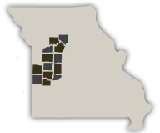

Bates, Benton, Carroll, Cedar, Chariton, Henry, Hickory, Johnson, Lafayette, Pettis, Saline, St. Clair and Vernon Counties

Workforce Development Board of Western Missouri, Inc. is an equal opportunity employer. Auxiliary aids and services are available upon request to individuals with disabilities. All voice telephone numbers on this e-mail may be reached by persons using TTY/TDD equipment via the Missouri Relay Service at 7-1-1.
Strategic Elements | Page 2
Operational Elements | Page 46
Program Elements | Page 59
List of Required Policies Attachments | Page 77 & 78
Table of Contents

Strategic Elements

1. Local Workforce Development Board’s Vision
State the Board’s vision for the Local Workforce Development Area (LWDA) and how this vision meets, interprets, and furthers the Governor’s vision in the current WIOA Missouri Combined State Plan.
The vision of the Workforce Development Board of Western Missouri, Inc. is to assess and respond to the training and employment needs of our workforce stakeholders in ways that restore and build competitive, robust local economies.
2. Local Workforce Development Board’s Goals

Provide the Board's goals for engaging employers and preparing an educated and skilled workforce (including youth and individuals with barriers to employment). Include goals relating to the performance-accountability measures based on primary indicators of performance to support regional economic growth and economic self-sufficiency.
- Support job training opportunities (OJT, Transitional Jobs, Incumbent Worker, Apprenticeships, Work Experience, Skill Certificates, etc.).
- Help businesses hire and retain a “skilled” workforce.
- Work with employers to identify career pathways within their company.
- Promote communication networks between companies, educational institutions and other stakeholders.
- Provide opportunities for Career and Job Fairs.
- Focus on training experiences for youth and individuals with barriers to employment.
- Engaged, Efficient and Effective Customer Service

Goal #1: Support job training opportunities (OJT, Transitional Jobs, Incumbent Woker, Apprenticeships, Work Experience, Skill Certificates, etc.
The following strategies support all of the performance measures:
- Placing participants in training opportunities that closely match their interest assessments.
- Addressing current and emerging skills gaps identified through sector partnerships.
- Enhancing the alignment of career services across all partner programs through an integrated model of service provision.
- Integrating work-based and classroom-based instruction.

Goal #2: Help businesses hire and retain a skilled workforce.

The following strategies support the performance measures: Employment Rate 2nd and 4th Quarter After Exit.

- Developing a pipeline of work-ready individuals by skilling-up people in need or work.
- Utilizing Incumbent Worker training in conjunction with OJTs.
- Continue to inform employers of the ACT National Career Readiness Certificate.
Goal #3: Work with employers to identify career pathways within their company. The following strategies support the performance measure: Effectiveness in Serving Employers.
- Informing local economic developers of services that can be provided to companies they are working with.
- Continuing to review the region’s career pathways regularly to ensure alignment with the skills needed by business and industry.
- Meet with businesses in the region to discuss career pathways.
- Utilizing Incumbent Worker Training to skill up employees in their career pathway to provide advancement and entry level openings.
Goal #4: Promote Communication between companies, educational institutions and other stakeholders. The following strategies support the performance measure: Effectiveness in Serving Employers.
- Working with local economic developers to bring industry sectors together for collaboration.
- Informing local economic developers of the programs available to business through job center services.
- Leverage opportunities to share information among employers and other partners.

Goal #5: Provide opportunities for Career and Job Fairs. The following strategies support the performance measure: Effectiveness in Serving Employers.

- Providing space within the Job Center for hiring events.
- Partnering with other organizations for Job Fairs.
Goal #6: Focus on training experiences for youth and individuals with barriers to employment. The following strategies support the performance measures: Employment Rate – 2nd and 4th Quarter After Exit.
- Encouraging co-enrollment of participants in multiple core programs.
- Providing wrap-around services to enable disadvantaged individuals to participate in job training.
- Executing outreach that targets specific audiences through social media to share information on work and training opportunities.

Goal #7: Engaged, Efficient and Effective Customer Service
- Working closely with individuals to understand their specific needs and using a holistic approach to address them.
- Supporting opportunities for staff to meet with and discuss services available through partners/ referrals.
- Continuing to offer virtual services and meet customers where they are.
- Understanding the needs of employers and creating solutions tailored to their specific needs.
3. Local Workforce Development Board’s Priorities

Identify the workforce development needs of businesses, jobseekers, and workers in the LWDA, and how those needs are determined.
The Board’s priorities are to address the needs of businesses, job seekers and workers. The workforce needs of the region are similar to those across the State of Missouri. #1 The impending retirement of older workers. #2 The upskilling of adults with no post-secondary degree/certificate. #3 To address the middle-skill job gap. #4 To educate youth on skills they need to obtain to enter the workforce.
These needs were determined by the Missouri Chamber Workforce 2023 study along with meetings with board members/commissioners, conversations with economic developers and employers and other partner meetings.
4. Local Workforce Development Board’s Strategies

Describe the Board’s strategies and goals for operation, innovation and continual improvement based on meeting requirements for the needs of businesses, job seekers and workers. Required strategies are listed below. Please describe the strategies and objectives for:
a. Strategy: Career Pathways
- Career pathways are reviewed frequently to ensure alignment with the skills needed by business and industry.
- Labor Market Information (LMI) is provided to job seekers to inform them of the best employment and career advancement opportunities.
- Certified Work Ready Communities data is reviewed to determine skills gaps which will aid educators in building career pathways to fill the industry needs.
b. Strategy: Employer Engagement
- Continuing to provide virtual Employer Workshops to inform them of services available through the job centers.
- Continuing to participate in Regional Planning Commission CEDS committee.
- Encouraging staff to meet with employers one-on-one to address their needs and to identify career pathways within their companies as well as working with them to hire and retain a skilled workforce.
- Working closely with economic developers in the region.
- Supporting job training opportunities.
- Providing opportunities for job fairs and hiring events.
- Continuing to work with the Office of Workforce Development’s Employer Engagement Team.
c. Strategy: Business Needs Assessment
- Conducting on-line business needs assessments with employers.
- Requesting on-line business survey responses as a follow-up after providing a job center service.
- Frequently reviewing business job orders and job postings.
d. Strategy: Alignment and Coordination of Core Program Services
- Convening regular meetings with WIOA Partners.
- Using appropriate referral methods amongst partners. Referral will be documented to include the method of referral and subsequent follow-up. Each referral will include an initial assessment, listing of services already planned, and the service requested of the agency receiving the referral.
- Braiding funding by multiple partners to afford clients more opportunities for jobs that lead to self-sufficient wages.
- Attending Inter-Agency meetings, Skill-up Partner meetings, etc.
- Requesting presentations with job center staff on services offered through partner programs.
e. Strategy: Coordination with Economic Development
- Maintaining membership on Pioneer Trails Regional Planning Commission’s Comprehensive Economic Development Strategy committee (CEDS).
- Gathering information about the needs of employers through meetings with community/regional/state economic development partners.
- Attending networking events hosted by economic partners.
- Attending Central Missouri Economic Alliance meetings.
f. Strategy: Outreach to Jobseekers and Businesses.
- Posting information on the job center’s Facebook pages.
- EO Officer conducting data analysis of programs and services annually to establish that all segments of the population in the region are being served. If it is determined any particular population is being underserved outreach plans will follow.
- Working with service providers and employers to promote veterans as highly skilled and experienced members of the workforce and to inform them of services available through the job centers.
- Participating in and conducting job fairs that promote employment and training opportunities where veterans can connect to businesses.
- Endorsing veteran job seekers through Consolidated Devops and Lvrs (CODL) to the community.
- Outreach is conducted through economic development events, regional employer meetings, forums, local human resource groups, industry association, Chambers of Commerce and board members/commissioners distributing information to the region’s communities.
g. Strategy: Access-improvements to Physical and Programmatic Accessibility
- MOUs will reflect the best possible means of providing access to partner programs whether that be in person, by phone or virtually.
- Providing assistive technology at both Job Center locations in the region.
- Providing Connection Points to enhance customer access to Job Center services. Various Connection Points are in place throughout the region and at least one is located in each county that does not house a job center.
- Meeting individuals in public locations that are convenient for them.
- Continuing to partner with the local community college and other training providers to improve access to activities leading to recognized postsecondary credentials and certifications.
- As part of the Job Center Certification process Accessibility Audits were conducted at each job center.
- Providing translated documents and forms when appropriate.
- Making the technology available to conduct meetings and collect documents/signatures virtually.
h. Strategy: Customer Service Training
- Functional Leaders will address customer service issues as needed whether in weekly staff meetings or one-on-one.
- Business/Customer Surveys are reviewed regularly and identified issues are addressed immediately.
- Training for job center staff will be provided in various ways such as in-person and webinars.
i. Strategy: Assessment
- Conducting initial assessments to identify skill level of participants which may include literacy, numeracy, English language proficiency, aptitudes – to include skills gaps, barriers to employment and supportive service needs.
- Utilizing assessment instruments to identify skill levels such as Talify and Missouri Connections. If the customer is under 18 Career Scope will be used to establish aptitude and interest in order to determine the best career path.
- Utilizing other assessment tools which may include *ONet, TABE and WorkKeys.

j. Strategy: Support Services
- Continuing to connect with partner programs to assist with supportive services needs such as transportation assistance, work uniforms, books, car repairs, childcare, housing, utilities, etc., to eligible individuals with barriers to gaining or retaining employment and/or gaining a credential.
- Continue assessment of need before supportive services are granted.
- Supportive service needs will be addressed at the time the need is identified.
- Encouraging job center staff to have conversations with customers they are working with to understand needs/barriers they may have.
k. Outcome measures assessment, monitoring and management.
- WDB staff present sub-state monitoring reports to the CLEOs and Full Board annually.
- CLEO Consortium and Full Board are kept informed of progress towards reaching performance outcome goals throughout the year.
- Quarterly monitoring is used to determine next steps for making progress towards meeting the negotiated goals.
- Performance data is closely analyzed to identify and then address performance challenges.
- WDB staff work closely with job center staff to explain how performance measures are affected and to train on ways to improve those outcomes.
5. Economic, Labor Market, and Workforce Analysis Source

Information/data taken from Missouri Economic Research and Information Cetner (MERIC). https://meric.mo.gov/about-us
6. Economic Analysis

Describe the LWDA’s current economic condition, including the following information by county (if your LWDA includes more than one county) and the overall region:
a. Average personal income level;
b. Number and percent of working-age population living at or below poverty level;

Personal Income

In the West Central Region, all counties were below the state average of $57,818 for per capita personal income, except Carroll County. In 2022, the per capita personal income in ten of the 13 counties in the West Central Region was above $40,000.

In 2022, personal income for the US and Missouri increased 2.0 percent and 3.2 percent respectively when compared to 2021.

The statewide poverty rate of working age persons, or those 18-64 years, was 12.3 percent in 2022. In the West Central Region, the poverty rate was lower than the state average in three counties. The county with the lowest poverty rate was Carroll (7.5%), followed by Lafayette (9.3%), and Chariton (10.8%). Counties with the highest poverty rates were Hickory (20.9%) and Cedar (19.8%).

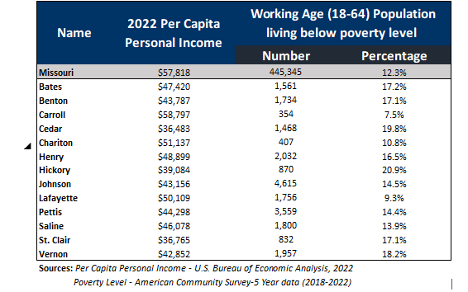

The remainder of this page left blank intentionally.

c. Number and percent of working age population determined to have a barrier to employment;

Barriers to employment can include homelessness, disability status, lower education levels, and limited proficiency with the English language. All but two counties in the West Central Region had a higher percentage of their working age population (18-64 years old) with disabilities, as compared to the state average of 12.3 percent, with the highest percentage in Hickory County (24.6%). The percentage of the working age population with English as a second language in Missouri was 7.1 percent. Pettis County (12.0%) and Saline County (9.1%) had higher percentage of the working age population with English as a second language than the state average.

In Missouri, 10.8 percent of the working age population did not have a high school diploma in 2022. Seven of the 13 counties in the region had a higher percentage of the working age population without a high school diploma than the state percentage. Saline County had the highest percentage of the working age population without a high school diploma at 13.7 percent whereas Chariton County had the lowest percentage of the working age population without a high school diploma at 9.0 percent.

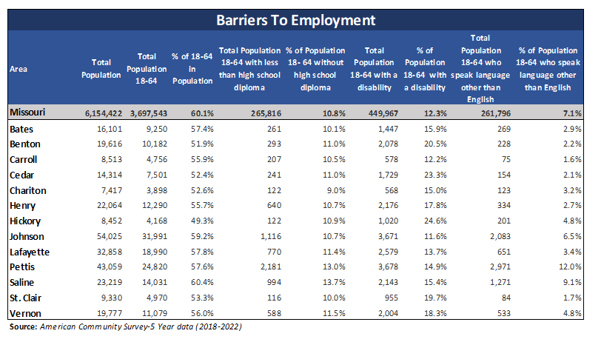

The remainder of this page left blank intentionally.

d. Unemployment rates for the last five years;

The unemployment rate in the West Central Region is declining after peaking in 2020 due to the COVID-19 pandemic. The unemployment rate for 2022 was close to the state average of 2.5 percent in several counties. Chariton County had the lowest unemployment rate at 2.1 percent. The highest unemployment rate was in Benton County, at 3.6 percent.
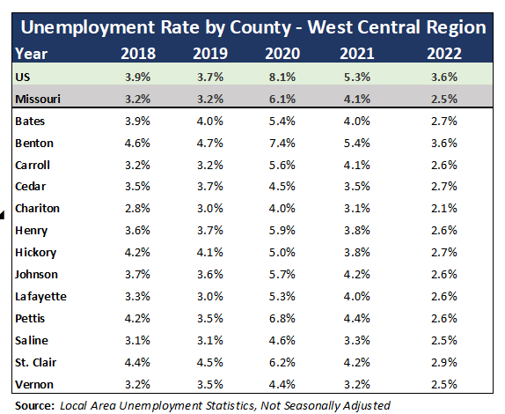

e. Major layoff events over the past three years and any anticipated layoffs; and
In PY22, CDI Head Start in Henry County laid off 66 individuals.
f. Any other factors that may affect local/regional economic conditions.
Childcare and transportation continue to be identified issues that affect economic conditions.

7. Labor Market Analysis

Provide an analysis of the LWDA’s current labor market including:
a. Existing Demand Industry Sectors and Occupations Provide an analysis of the industries and occupations for which there is existing demand.
Current Industry Demand

The West Central Region had a negative compound annual growth rate of -1.7 percent over the 5-year period from 2017 to 2022. However, eight industry groups had a positive growth rate over the same time period. Those industries included Transportation and Warehousing (360 employment increase at 4.8% compound annual growth rate); Professional, Scientific, and Technical Services (241 at 3.1%); Construction (440 at 3.0%); Arts, Entertainment, and Recreation (67 at 2.2%); Other Services (except Public Administration) (159 at 1.7%); Manufacturing (981at 1.6%); Real Estate and Rental and Leasing (43 at 1.4%); and Accommodation and Food Services (206 at 0.6%).

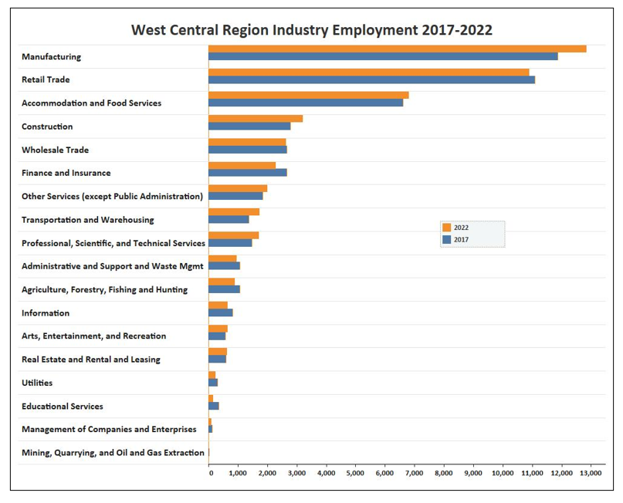
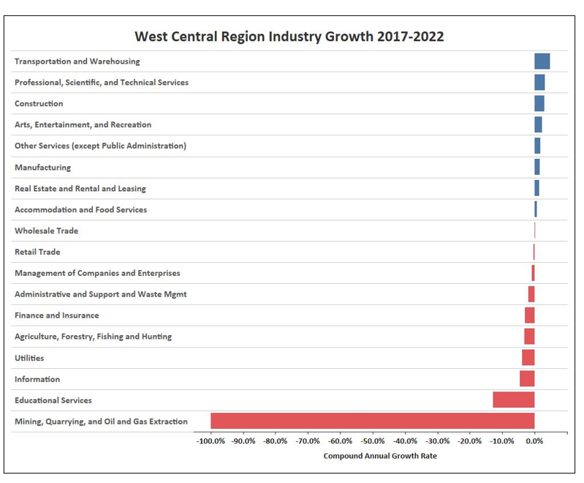

The remainder of this page left blank intentionally.

Location Quotient
Location Quotient (LQ) describes the concentration of an industry in a geographic region in relation to the nation. The national average is 1.0. Industries with an LQ higher than 1.0 indicate an above average concentration of that industry in the area.
In 2022, West Central Region had 11 industries with LQs of 1.5 or higher, including Gasoline Stations and Fuel Dealers (3.3); Animal Production and Aquaculture (2.8); Primary Metal Manufacturing (2.3); Machinery Manufacturing (2.2); Fabricated Metal Product Manufacturing (2.1); Crop Production (2.0); Nursing and Residential Care Facilities (2.0); Food Manufacturing (2.0); Support Activities for Agriculture and Forestry (1.8); General Merchandise Retailers (1.6); and Motor Vehicle and Parts Dealers (1.5) .

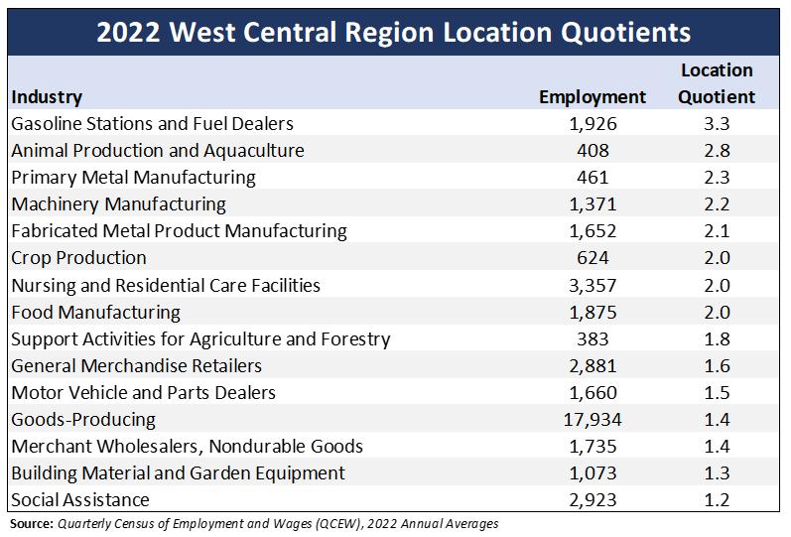

The remainder of this page left blank intentionally.

Current Occupational Demand
Current occupational demand can be attained through the job ads placed by employers. From November 2022 to October 2023, nearly 16,660 on-line job ads were placed for jobs located in the West Central Region according to LightcastTM.
Job ads were placed for positions at every skill and education level. Missouri uses a system of Now, Next, and Later to categorize jobs according to the typical education and experience required for success on the job. Now jobs typically require a high school education or less and short-term training. Next jobs typically require moderate to long-term training or experience or education beyond high school. Later jobs typically require a bachelor’s degree or higher education.
Now occupations with the highest number of job postings included Home Health and Personal Care Aides; Retail Salespersons; Fast Food and Counter Workers; Laborers and Freight, Stock, and Material Movers, Hand; and Customer Service Representatives.
Occupations with the most job postings in the Next category were Licensed Practical and Licensed Vocational Nurses; Food Service Managers; Heavy and Tractor-Trailer Truck Drivers; First-Line Supervisors of Retail Sales Workers; and Nursing Assistants.
Later occupations with the highest number of job postings were Registered Nurses; Medical and Health Services Managers; Physical Therapists; Postsecondary Teachers; and Managers. All Other.
Many of the occupations with the most job postings also have high numbers of projected openings through 2030. The occupations with high numbers of job postings and high numbers of projected annual openings are identified with the star.

The remainder of this page left blank intentionally.

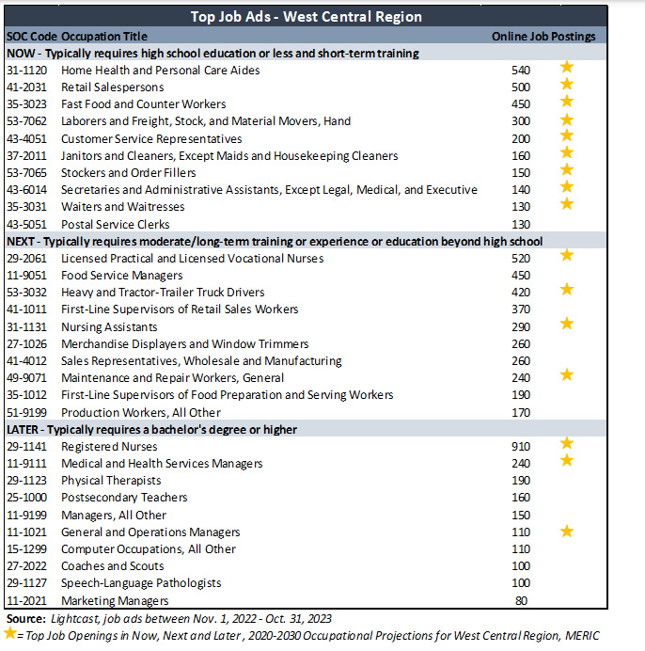

Missouri Workforce 2023 Survey
From February 20, 2023, to April 17, 2023, over 2,800 Missouri companies with five or more employees were surveyed to gauge the state of the workforce from the employer’s perspective. A total of 1,705 employers started the survey but did not respond to all questions, and 1,183 employers completed every question in the survey. Seventy-three percent employers responded over the phone and 27 percent completed the online version of the survey. Companies were asked 26 questions, some with multiple parts, about hiring trends, skill needs and shortages, workforce initiatives, recruitment strategies, and education and experience requirements.
Companies interviewed were randomly selected from a categorized list of Missouri businesses from the Data Axle employer database. The sample was selected to be representative of Missouri’s industry sectors and workforce regions. Regional quotas were based on the region’s share of employment relative to the state. Over half (51%) of employers surveyed had 11-49 employees. The industries selected for the survey were chosen to represent a composite picture of the state’s industry mix with a statistically significant sample surveyed from each of the industry sector matching the approximate ratio of these industries across the state.
To gauge employment trends, employers were asked about their staffing levels and future hiring plans. When asked about employment changes over the last 12 months, half (50%) said that employment levels (total employment) remained the same as before (47% in 2021, 57% in 2020, and 48% in 2019). In 2019, more employers reported increasing employment levels rather than decreasing (21% reporting a significant or slight decrease compared to 32% reporting a significant or slight increase). This flipped in 2020 and 2021, mostly due to the COVID-19 pandemic. In 2023, about 28 percent of surveyed employers reported increased employment levels, either slightly or significantly, while 22 percent reported significant or slight decrease in employment levels.
For the third year in a row, hiring new full-time employees remained the top method of expanding employment, with 75 percent of employers stating they would hire new full-time employees. Fifty-nine percent of employers reported they would hire part-time employees.
Employers were asked about the barriers they encountered in expanding employment. Lack of applicants overall was a new option for employers in the 2023 survey, and 66 percent of surveyed employers selected this option, making it the top barrier to expansion of employment. The next highest barriers were shortage of applicants with knowledge or skills and economic conditions, which have been the top cited barriers since the survey began in 2019. Shortage of applicants with knowledge or skills increased significantly from previous years, from 47 percent in 2019 and 2020, to 60 percent in 2021, and 65 percent in 2023. Economic conditions as a barrier to employment decreased from 37 percent in 2021 to 30 percent in 2023. Similarly, fewer employers encountered government policies or regulations as a barrier to expanding employment, dropping from 30 percent in 2021 to 13 percent in 2023.
Other significant barriers encountered in 2023 included lack of childcare and transportation access, with 21 percent of respondents reporting these as barriers to expanding employment.
The survey also asked employers to rate the importance of each barrier on a scale of one to five, with one being insignificant and five being critical. The highest weighted average response for any barrier cited this year was lack of applicants overall, getting an importance score of 4.05 out of 5. The next highest weighted response was government policies or regulations (3.88), followed by shortage of applicants with knowledge or skills (3.85). Although the share of employers choosing government policies or regulations as a barrier to employment expansion has decreased, for those that did encounter it, it was still a critical barrier. Shortage of available training programs dropped in importance from 3.98 in 2019 to 3.15 in 2023.
Companies employ workers in a variety of functional areas with different work responsibilities. Patient Care and Skilled Trades functional areas had the largest percentage of employers reporting shortages of skilled applicants at 65 percent each. Skill shortages in Customer Service have increased substantially, increasing from 25 percent in 2019 and 31 percent in 2020, to 47 percent in 2021, decreasing slightly to 45 percent in 2023.
To address the problem of skill shortages in the current workers, employers use several remedial measures, and on-the-job-training remains the most preferred method. Over 9 in 10 employers (91%) stated they used on-the-job training to assist current workers in addressing the need for new or increased skills. However, there is a significant decrease in applying these remedial measures in 2023 when compared to 2021, most significantly in providing a flexible schedule to pursue outside continuing education (67% in 2021 vs. 46% in 2023) and in-house classroom training (60% in 2021 vs. 41% in 2023).
Relatedly, employers were also asked if there was any change over the last two years in flexibility for hiring applicants with less than the advertised preferred level of qualifications in education, experience, and skill level. Most employers said they stayed about the same in flexibility for hiring applicants. The majority that changed became more flexible in their consideration of applicants. Twenty-three percent of employers were more flexible with education requirements, 31 percent were more flexible with experience level requirements, and 29 percent were more flexible on skill level requirements.
Since the COVID-19 pandemic, there has been an increased interest in understanding remote work. Prior to pandemic, (February 2020) about 15 percent employers were having some workers working remotely. Remote work peaked in 2020 during the height of the pandemic, with over half of employers (56%) stating they had some workers working remotely, either full or part-time. This dropped significantly to 20 percent in 2021 and has increased slightly to 25 percent in 2023. When asked if they expected the number of remote workers to change over time, the vast majority (92%) of employers said they expected it to stay the same. In the question about workforce initiatives considered in the coming year, 13 percent of employers indicated considering remote work.
Employers evaluated various business concerns for the future on a scale of one to five, with one being not concerned and five being very concerned. Employers were most concerned about attracting or retaining talent, with a weighted average of 3.7. Several concerns decreased in importance from 2021, including lack of information for decision making (2.92 in 2021 vs. 2.38 in 2023) and supply chain disruptions (3.61 in 2021 vs. 3.1 in 2023). Cost of health insurance was among the major concerns reported in the 2023 survey.
Although employers are optimistic about expanding employment, with 44 percent planning to increase employment levels over the next 12 months, they continue to struggle to find skilled applicants. Sixty-two percent of employers had positions that took over 30 days to fill. A lack of overall applicants and shortage of applicants with knowledge or skills were the top barriers to expanding employment, with the shortage of applicants with knowledge or skills at the highest reported level it has been since the first survey in 2019. The most important business concern for employers was attracting and retaining talent. To try and retain existing workers, employers have increased wages (86%), offered a flexible work schedule (64%), or offered additional training (52%). Responses to this survey reinforce the widely-held experience of a tight labor market and difficulty finding workers.

The remainder of this page left blank intentionally.

b. Emerging Demand Industry Sectors and Occupations Provide an analysis of the industries and occupations for which demand is emerging.
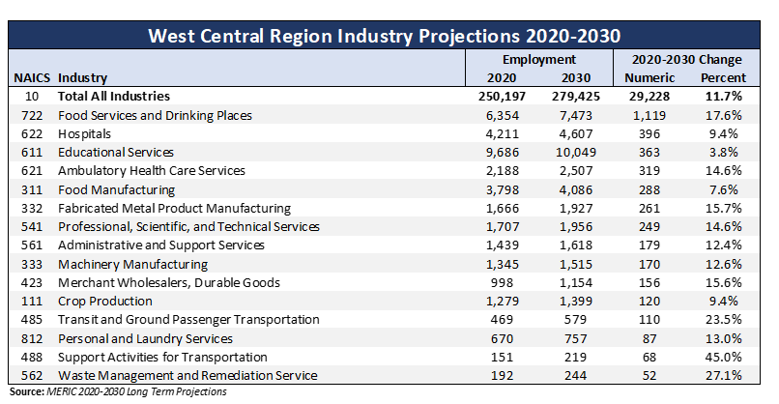

Occupational Projections
Job openings occur due to three reasons – exits, transfers, and growth. Exits occur as people leave the workforce for reasons such as retirement. Transfers occur when workers leave one occupation for a different occupation. Occupational growth occurs as businesses grow and need more workers to serve their customers.
Emerging occupations can be identified through projected growth openings. The following chart identifies occupations that have the highest number of annual growth openings in the region. Total openings are the sum of transfers, exits, and growth, and indicates the projected number of vacancies that businesses will need to fill each year.
Missouri uses a system of Now, Next, and Later to categorize occupations according to these levels. Now jobs typically require a high school education or less and short-term training. Next occupations typically require moderate to long-term training or experience or education beyond high school. Later occupations typically require a bachelor’s degree or higher.
Growth openings are projected at all education and training levels. Occupations in the table below are listed by the highest number of growth openings. Now occupations with the highest numbers of projected growth openings were Home Health and Personal Care Aides; Waiters and Waitresses; Passenger Vehicle Drivers, Except Bus Drivers, Transit and Intercity; and Laborers and Freight, Stock, and Material Movers, Hand. Next occupations with the highest numbers of projected growth openings were Cooks; Heavy and Tractor-Trailer Truck Drivers; and Welders, Cutters, Solderers, and Brazers. Later occupations with the most projected growth openings were Registered Nurses; General and Operations Managers; Secondary School Teachers, Except Special and Career/Technical Education; and Medical and Health Services Managers.
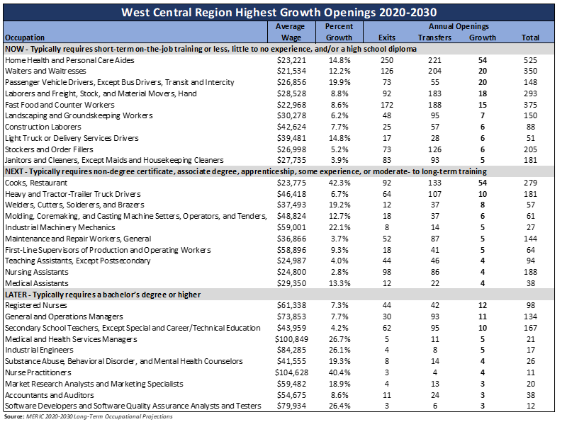

c. Employers’ Employment Needs Identify the job skills necessary to obtain current and projected employment opportunities. With regard to the industry sectors and occupations, provide an analysis of the employment needs of employers. Describe the knowledge, skills, and abilities required, including credentials and licenses.
Real-Time Labor Market Data
Job ads placed by employers offer another source of information on the knowledge, skills, and certifications requested by Missouri’s employers. LightcastTM is a data tool that spiders to over several thousand different web sites with job ads. The information found in the ads are placed in a database that can be queried to gain insight on employer needs.
The following table lists the specialized skills, certifications, and software and programming abilities requested most frequently by employers in job ads.
Generally, in the software and programming category, Microsoft Office and its products such as Word, Excel, PowerPoint, and Access rank at the top of the list across all industries. Therefore, in the following list, these Microsoft products have not been included as those tend to crowd the list by appearing at the top across all the industries. Industry-specific programs identified in the job ads are listed in the table.
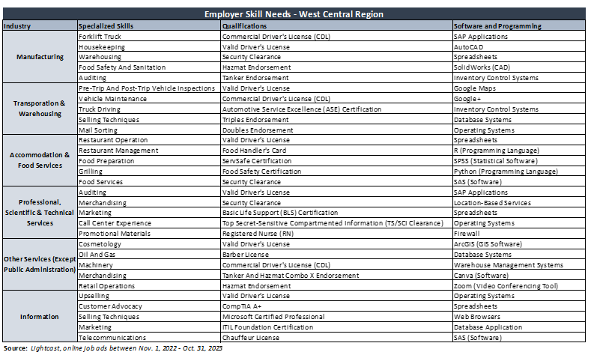

8. Workforce Analysis

Describe the current workforce, including individuals with barriers to employment, as defined in section 3 of WIOA . This population must include individuals with disabilities among other groups in the economic region and across the LWDA.
a. Employment and Unemployment Analysis Provide an analysis of current employment and unemployment data and trends in the LWDA.

Population Data

The U.S. Census Bureau estimates that Missouri’s population grew to over 6.15 million in 2022, up by 0.2 percent from the previous year. In the West Central Region over the past year, four of the 13 counties declined in population. The highest population increase, in the past year, was in Benton County, adding over 265 residents from 2021 to 2022. Pettis County had the largest population growth over the five-year span from 2017 to 2022, with an increase of 750 residents.
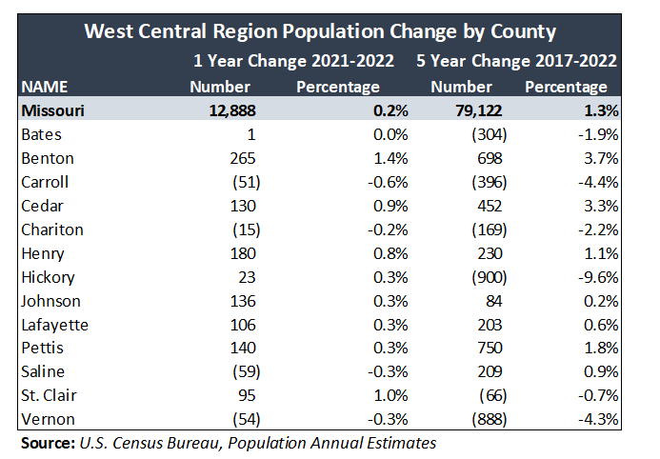

Demographics

In some ways, the West Central Region’s population shows similar trends as that of Missouri’s population. Overall, for Missouri, 25.0 percent of the population was under the age of 20 years in 2022. Seven of the West Central Region’s counties had percentage above the Missouri average for those under age 20. Pettis County had the highest percentage of its population under age 20 (27.7%). The percentage of population aged 55 and up was above the state average of 30.6 percent in ten of the 13 counties. The county with the highest percentage of residents age 55 and up was Hickory County with 50.7 percent of its residents in this age group.

Two of the 13 counties in the West Central Region had a higher female population than male population. The Missouri statewide average was 49.4 percent male and 50.6 percent female. Johnson County had the highest percent of male population (51.2%), while Vernon County had the highest percent of female population (50.6%).

Race statistics in the West Central Region were generally different from the Missouri averages. All counties in the region had a lower percentage of racial minorities than the statewide average. Three counties had a Hispanic or Latino population higher than the Missouri average of 4.6 percent. Saline County had the highest Hispanic or Latino population at 11.1 percent.

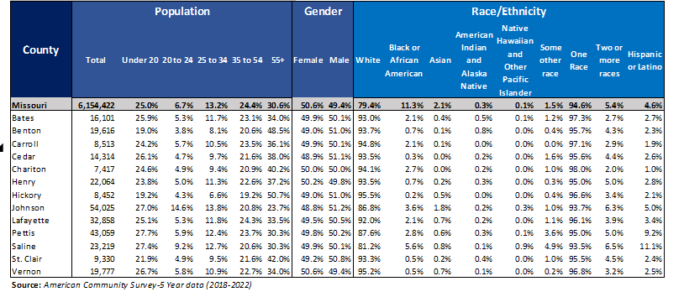

Employment and Unemployment

The number of West Central Region residents in the labor force has decreased from 122,357 in 2018 to 122,033 in 2022. The unemployment rate for the region jumped to 5.6 percent in 2020 because of the COVID-19 pandemic. However, 2021 and 2022 data show continuation of recovery with the unemployment rate decreasing to 4.0 percent and 2.7 percent respectively.
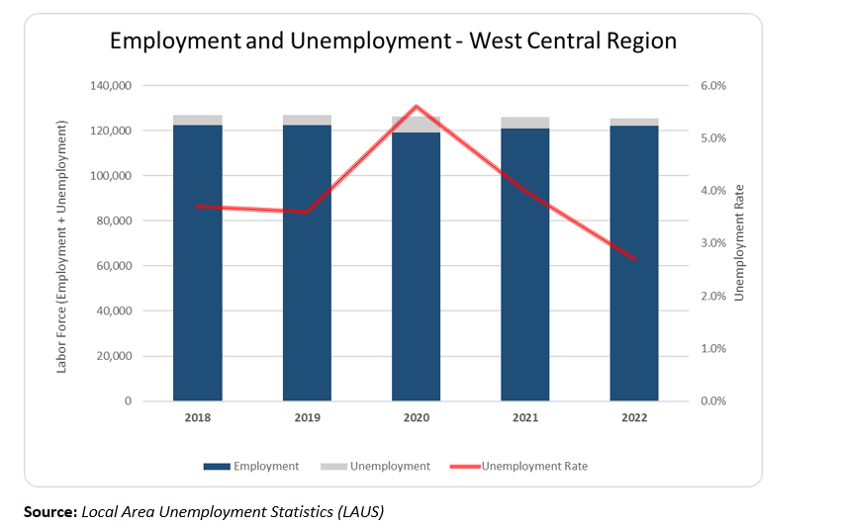

Labor Force Participation

The labor force is the sum of employed and unemployed persons. The labor force participation rate is the labor force as a percent of the civilian population 16 years and older. Using American Community Survey, 5-year data through 2022, Missouri’s labor force participation rate was 62.5 percent. In comparison, the rate for the West Central Region was lower, at 56.3 percent. The county with the highest labor force participation rate in the region was Pettis County (62.5%) and the lowest was Hickory County (38.9%).
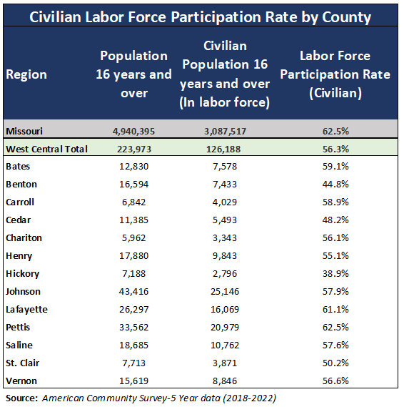

The remainder of this page left blank intentionally.

b. Labor Market Trends Provide an analysis of key labor-market trends, including across existing industries and occupations.
In-Demand Occupations
Over the long term, industry needs for certain occupations grow while for others decline. A trained and ready workforce is needed to fill employer demand and offer job seekers bright prospects of employment.
Long-term projections are produced in each state in conjunction with the Bureau of Labor Statistics. Since economies vary throughout the state, projections are also generated for the 10 regions in the state and provide insight on the occupations that are growing and declining. The total number of openings account for three different types of vacancies - exits, transfers, and growth. Exits occur as individuals leave the workforce for reasons such as retirement. Transfers occur as a person leaves an occupation to work in a different occupation. Growth simply means that more people are needed to work in the occupation. No matter the reason for the vacancy, skilled workers are needed to fill the job openings.
Missouri adds value to the standard projections template by including the ACT Workkeys Assessment Levels typically required for success in each of the 800+ occupations. Since most of Missouri’s counties participate in the Certified Work Ready Communities program, the levels help those researching careers find good options based on their personal assessment.
Missouri uses a system of Now, Next, and Later to categorize the occupations according to the training and education typically required for success on the job. Now occupations typically require a high school education or less along with short-term training. Next occupations typically require moderate to long-term training or experience and/or education beyond high school. Later occupations typically require a bachelor’s degree or higher.
While long-term projections offer a solid understanding of longer-term employer needs, job ads placed by employers help in recognizing the current needs of employers. When projections predict a high number of future openings and job ads show current demand for the same occupation, the occupation may be a good career possibility.
The table below displays the top five jobs by the number of projected openings for the 10-year projection period through 2030 in the Now, Next, and Later categories for the region. The flame beside some of the occupations represents “hot jobs” determined by the number of job ads placed by employers.
The Now occupations with the most annual job openings were Home Health and Personal Care Aides (525); Waiters and Waitresses (458); Passenger Vehicle Drivers, Except Bus Drivers, Transit and Intercity (375); Laborers and Freight, Stock, and Material Movers, Hand (350); and Fast Food and Counter Workers (293). A main reason for the high number of openings in these occupations was transfers and exits.
Occupations with the highest number of annual openings in the Next category were Cooks, Restaurant (279); Heavy and Tractor-Trailer Truck Drivers (188); Welders, Cutters, Solderers, and Brazers (181); Molding, Coremaking, and Casting Machine Setters, Operators, and Tenders (144); and Industrial Machinery Mechanics (125).
Later occupations with the highest number of annual openings were Registered Nurses (167); General and Operations Managers (134); Secondary School Teachers (98); Medical and Health Services Managers (53); and Industrial Engineers (41).
Many high demand occupations correspond directly with certain industry sectors, such as Health Care, Educational Services, and Retail. Other high demand occupations, such as Secretaries and Administrative Assistants and General and Operations Managers are found in many different industry sectors.
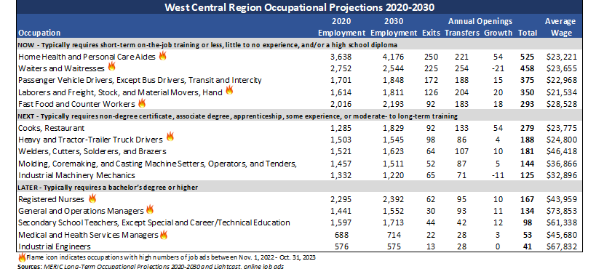

The remainder of this page left blank intentionally.

c. Education and Skills Levels of the Workforce Analysis Provide an analysis of the educational and skills levels of the workforce.
Educational Attainment
Educational attainment is a measure of the highest level of education obtained by individuals aged 25 and up, or the population generally in the workforce. Ninety-two percent of Missouri’s population age 25 and over was a high school graduate or higher in 2022. About 19 percent held a bachelor’s degree and 12 percent held a graduate or professional degree.
The West Central Region had a higher percentage, than the state average, of people whose highest educational attainment is high school, less than high school, or an associate degree. Missouri had a higher percentage of people with a bachelor’s or graduate or professional degree.
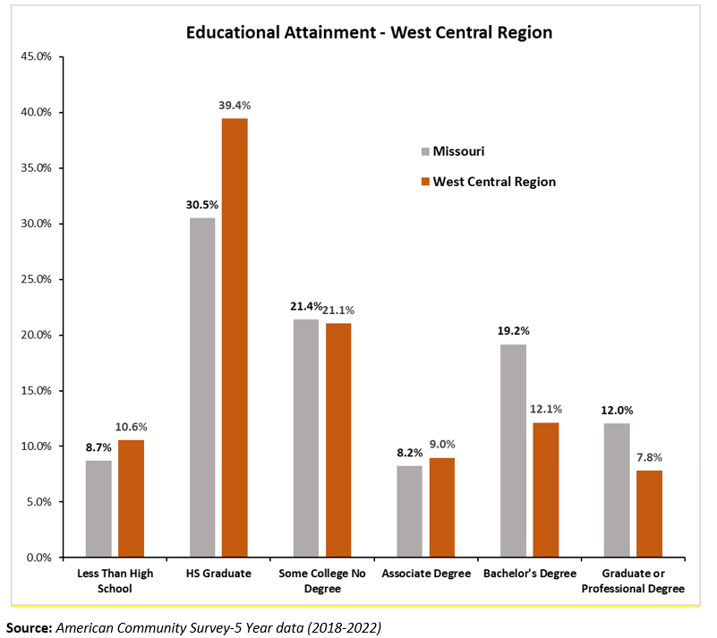

Occupational Projections
Long-term projections are used to identify the fastest growing occupations, as well as occupations with a high number of openings through 2030.
The growth rate of an occupation measures the percentage of job growth by an occupation between the base year and projected year. In 2022, in the West Central Region, the occupations requiring a graduate degree are projected to have the fastest growth rate (7.2%), followed by occupations requiring a bachelor’s degree (6.0%).
Long-term projections also present data on expected job openings for each occupation through 2030. Openings in an occupation can occur due to an occupation growing, workers moving into a different occupation, or workers leaving the workforce entirely. No matter the reason, qualified individuals are still needed to fill job vacancies. Most openings will be in entry-level jobs, mostly due to high turnover rates as workers either transfer to other occupations or leave the workforce.
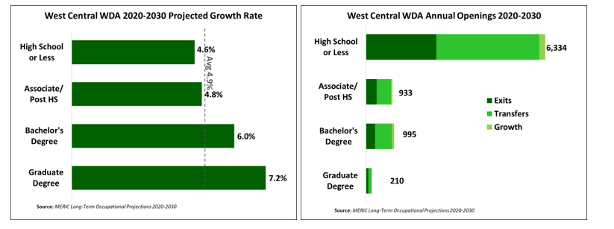
d. Skills Gaps Describe apparent “skills gaps” in the local area. How are the “skills gaps” determined?
Missouri Workforce 2023 Survey
The Missouri Employer Survey has been conducted four times since 2019. Some questions have remained consistent each year, and others have changed to reflect current issues impacting the state’s employers. Methodologies were held as consistent as possible from year-to- year. Comparisons to previous years are made throughout the report where applicable, but each survey indicates a snapshot in time. It can be used to infer changing trends in the labor market and employer sentiment but was not designed as a stringent time series analysis.
Missouri has more than 230,000 payroll employers who provide jobs to over 2.8 million people. Understanding the current hiring trends and challenges faced by the state’s employers is essential not only in providing targeted resources and services to help these employers but also in supporting the state’s economic and workforce development. Keeping these objectives in view, over 2,800 Missouri companies with five or more employees were surveyed from February 20, 2023, to April 17, 2023. This helped gauge the state of the workforce from the employer’s perspective, with 1,183 employers completing the survey. Throughout the report, data in the graphs may not add to 100 percent due to rounding or the ability to select more than one response.

A few takeaways from this survey include:
- Employer’s main concerns are hiring and retaining top talent.
- Sixty-two percent of employers had job postings that took more than 30 days to fill.
- The top barrier to expanding employment is a shortage of applicants with knowledge or skills, which has increased significantly from previous years (47% in 2019 and 2020, 60% in 2021, and 65% in 2023).
- Most employees work in person vs. working remotely.
- The top strategy used to retain existing workers is offering increased wages.
- Eighty-nine percent of surveyed employers have increased wages at an average of 11 percent in the last 12 months.
Difficulty hiring quality employees was a constant theme throughout the survey. Sixty-two percent of employers reported they had some positions that took over 30 days to fill and 38 percent reported to have their vacant positions filled in less than 30 days.
Fifteen percent reported 75-100 percent of their vacant positions took over 30 days to fill. Jobs that were the hardest to fill were in healthcare; particularly nursing occupations; sales; and food service.
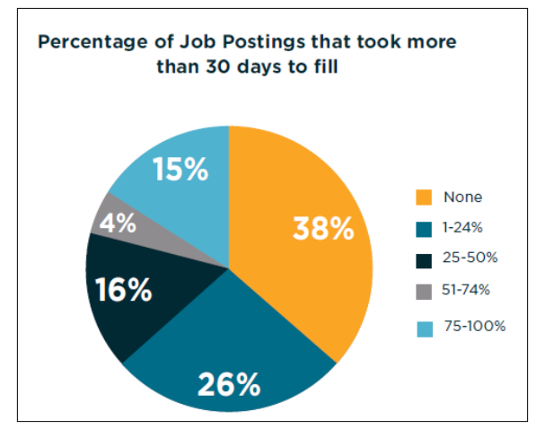
Employers were asked about the barriers they encountered in expanding employment. Lack of applicants overall was a new option for employers in the 2023 survey, and 66 percent of surveyed employers selected this option, making it the top barrier to expansion of employment. The next highest barriers were shortage of applicants with knowledge or skills and economic conditions, which have been the top cited barriers since the survey began in 2019. Shortage of applicants with knowledge or skills increased significantly from previous years, from 47 percent in 2019 and 2020, to 60 percent in 2021, and 65 percent in 2023. Economic conditions as a barrier to employment decreased from 37 percent in 2021 to 30 percent in 2023. Similarly, fewer employers encountered government policies or regulations as a barrier to expanding employment, dropping from 30 percent in 2021 to 13 percent in 2023.
Other significant barriers encountered in 2023 included lack of childcare and transportation access, with 21 percent of respondents reporting these as barriers to expanding employment.
The survey also asked employers to rate the importance of each barrier on a scale of one to five, with one being insignificant and five being critical. The highest weighted average response for any barrier cited this year was lack of applicants overall, getting an importance score of 4.05 out of 5. The next highest weighted response was government policies or regulations (3.88), followed by shortage of applicants with knowledge or skills (3.85). Although the share of employers choosing government policies or regulations as a barrier to employment expansion has decreased, for those that did encounter it, it was still a critical barrier. Shortage of available training programs dropped in importance from 3.98 in 2019 to 3.15 in 2023.
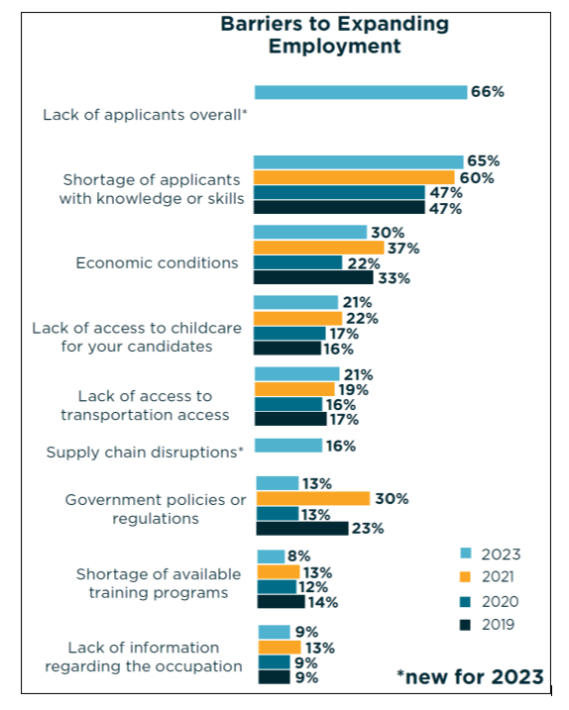

Sixty-one percent of employers stated they were experiencing a shortage of skilled applicants. This is slightly lower than the 68 percent reported in 2021 and much higher than the 28 percent cited in 2019.
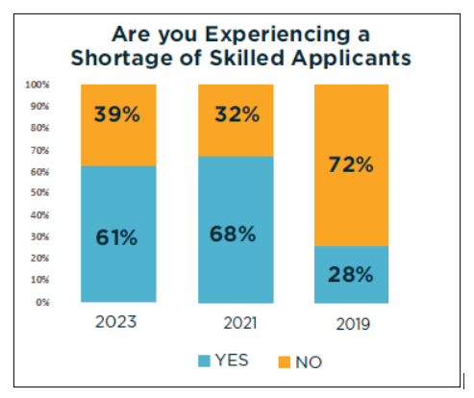
Employers were asked about possible shortcomings of applicants. As in previous years, poor work habits is the most frequently cited shortcoming at 64 percent (68% in 2021 and 70% in 2019). Other top shortcomings include lack of general business or industry knowledge (55% in 2023, 58% in 2021, and 43% in 2019) and lack of critical thinking and problem solving (54% in 2023, 59% in 2021, and 49% in 2019).
Since 2019, large changes have occurred in two less frequently mentioned shortcomings – inability to interact effectively with people of different cultures and socio-economic backgrounds and inability to pass a drug test or having a substance abuse issue. In 2019, 44 percent of employers cited applicant’s inability to interact effectively with people of different cultures and socio-economic backgrounds as a shortcoming. This dropped to 24 percent in 2021 and 2023. Inability to pass drug test or has substance abuse issue increased from 6 percent in 2019 to 30 percent in 2021 and 26 percent in 2023.

The remainder of this page left blank intentionally.

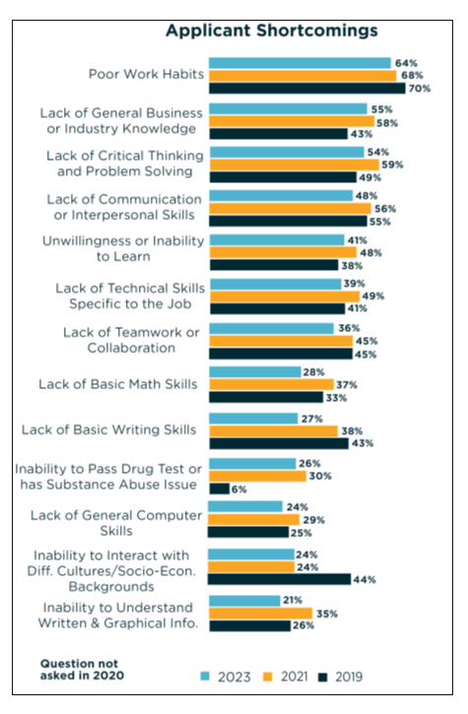

Employers were also asked to rate importance of each shortcoming on a scale of one to five, with one being insignificant and five being critical. Poor work habits was the most cited shortcoming and also ranked as the most important, with an average importance score of 4.19 out of 5.0. Poor work habits was also ranked the highest shortcoming in 2019 and 2021. Other high-ranking shortcomings are unwillingness or inability to learn (4.04) and inability to pass a drug test (3.98).
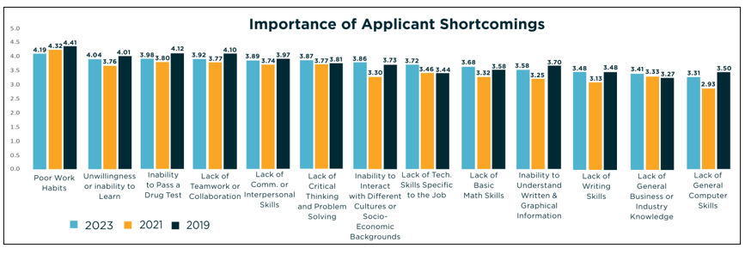

Sixty-one percent of employers stated they were experiencing a shortage of skilled applicants. This is slightly lower than the 68 percent reported in 2021 and much higher than the 28 percent cited in 2019.

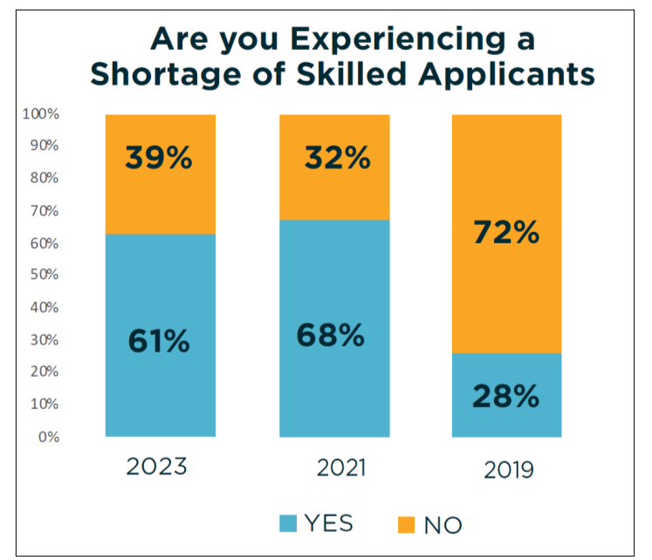
Employers take a variety of measures to address these shortages. Following the trend of previous years when this question was asked from the employers, 80 percent of the respondents reported hiring less experienced workers and train them as a measure to address skill shortages in the applicants (81% in 2021 and 87% in 2019). Other popular remedial measures were offering increased wages (67%) and offering flexible work schedules (52%). Offering increased wages rose as a remedial measure from 49 percent of respondents in 2019 to 64 percent in 2020 and 67 percent in 2023. Some less widely used measures, such as investing in automation instead of hiring, hiring from outside the United States, and hiring contractors, have decreased over the last four years.
Investing in automation instead of hiring decreased from 30 percent in 2019 to 8 percent in 2023, hiring from outside the United States decreased from 12 percent in 2019 to 5 percent in 2023, and hiring contractors went from 27 percent in 2019 to 14 percent in 2023. Other remedial measures to alleviate the shortage of skilled applicants that were included in the 2023 survey were offering flexible work schedules (52%), offering health insurance (48%), providing a one-time bonus (28%), offering more paid time off (20%), using a temporary agency (16%), and offering remote work (10%).

The remainder of this page left blank intentionally.

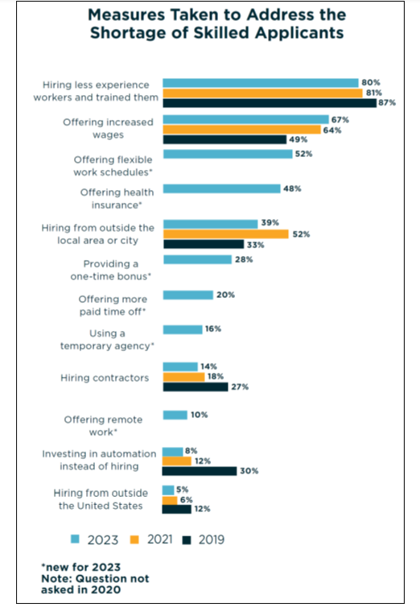

Companies employ workers in a variety of functional areas with different work responsibilities. Patient Care and Skilled Trades functional areas had the largest percentage of employers reporting shortages of skilled applicants at 65 percent each. Skill shortages in Customer Service have increased substantially, increasing from 25 percent in 2019 and 31 percent in 2020, to 47 percent in 2021, decreasing slightly to 45 percent in 2023.
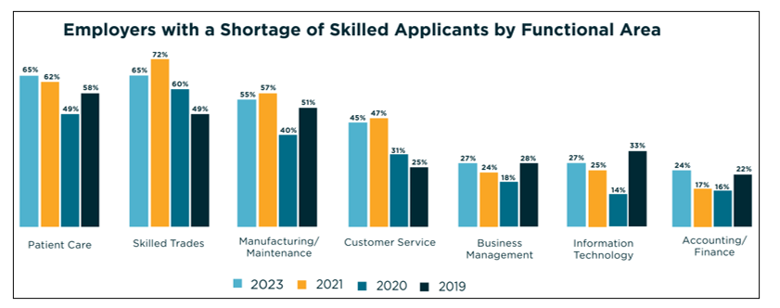

To address the problem of skill shortages in the current workers, employers use several remedial measures, and on-the-job-training remains the most preferred method. Over 9 in 10 employers (91%) stated they used on-the-job training to assist current workers in addressing the need for new or increased skills. However, there is a significant decrease in applying these remedial measures in 2023 when compared to 2021, most significantly in providing a flexible schedule to pursue outside continuing education (67% in 2021 vs. 46% in 2023) and in-house classroom training (60% in 2021 vs. 41% in 2023).

The remainder of this page left blank intentionally.

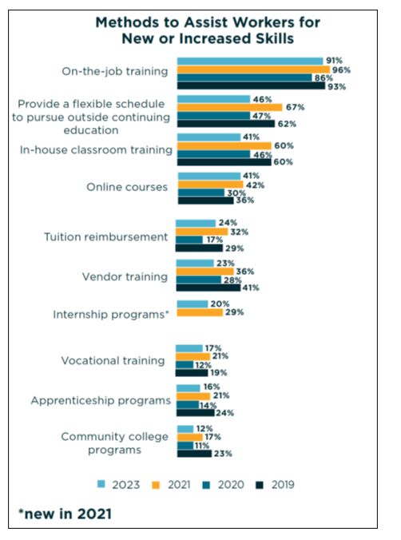

As the economy evolves, customer and workforce needs change. Now more than ever businesses have to adapt to attract and retain quality employees, as well as serve customer’s changing needs. Employers were asked which workforce initiatives they were considering for the next year.
Employer’s likelihood to consider a variety of initiatives has changed significantly over the last three years. From 2020 to 2021, a large number of employers were considering these workforce initiatives. However, from 2021 to 2023, responses were lower for almost all initiatives. The remote working option decreased significantly from 21 percent in 2021 to 13 percent in 2023, indicating a return to physical/centralized workspaces.
The top workforce initiative considered for the next year by employers was cross-training and knowledge transfer (67%), followed by increased employee care and engagement (53%) and reskilling or upskilling employees to new ways of working (46%).

The remainder of this page left blank intentionally.

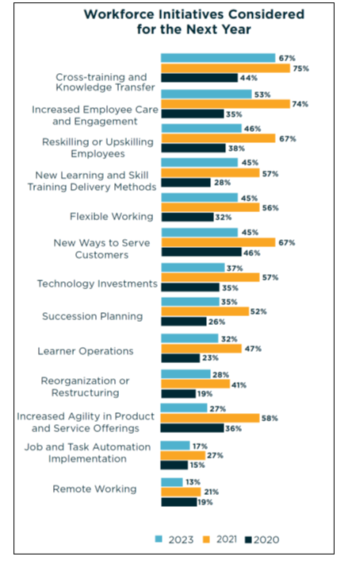

Since the COVID-19 pandemic, there has been an increased interest in understanding remote work. Prior to pandemic, (February 2020) about 15 percent employers were having some workers working remotely. Remote work peaked in 2020 during the height of the pandemic, with over half of employers (56%) stating they had some workers working remotely, either full or part-time. This dropped significantly to 20 percent in 2021 and has increased slightly to 25 percent in 2023. When asked if they expected the number of remote workers to change over time, the vast majority (92%) of employers said they expected it to stay the same. In the question about workforce initiatives considered in the coming year, 13 percent of employers indicated considering remote work.
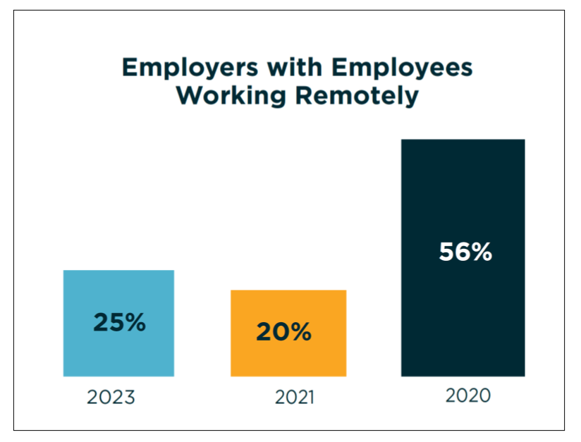

Employers may perform a variety of screening processes before hiring an employee. Criminal checks were the most common types of background checks conducted prior to hiring, with 74 percent of Missouri employers reporting they perform one. Drug screens were next at 46 percent. In 2023, background screenings involving professional license or certification, social media, drug screen, and financial checks decreased significantly from 2021.
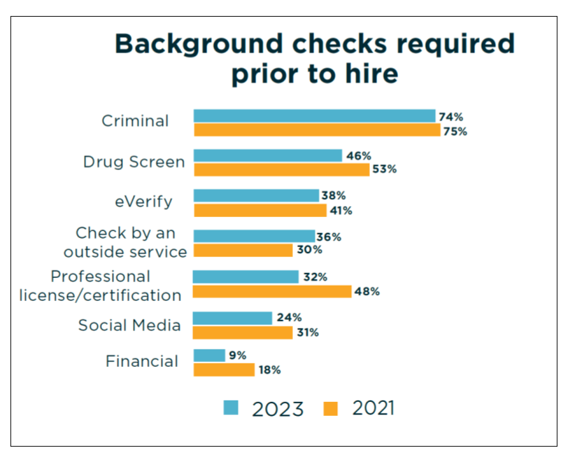

In 2019, less than one percent of Missouri employers would not consider hiring an applicant convicted of a felony offense who had completed his or her sentence and/or probation. This increased to 20 percent in 2020, was at 19 percent in 2021 and decreased slightly to 16 percent in 2023. Most employers (62%) reported it would depend on the nature of the felony and time of the offense, a significant increase from previous surveys Employers responding they would consider for any job they are qualified for decreased from 17 percent in 2020 and 2021 to 10 percent in 2023.
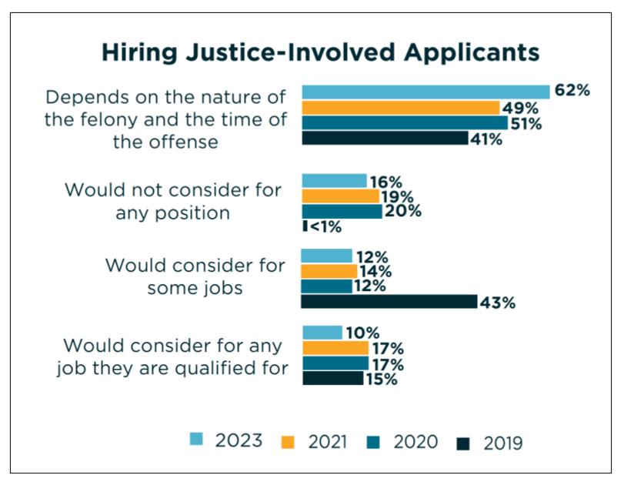

The top strategies used by employers in the last 12 months to retain existing workers included offering increased wages (86%), offering a flexible work schedule (64%), and offering additional training (52%). Remote work was listed as a strategy by only 13 percent of employers. When asked, “Have you increased wages in the last 12 months,” 89 percent of employers said yes. Of the employers who increased wages, the average increase was 11 percent.
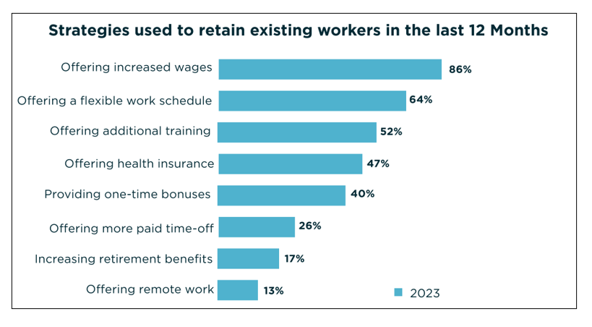

9. Workforce Development, Education and Training Activities Analysis

Describe the workforce development services and activities, including education and training in the LWDA, to address the education and skills needs of the workforce. Include education and training activities of the core programs and mandatory and optional One-Stop Delivery System partners.
a. The Strengths and Weaknesses of Workforce Development Activities Provide an analysis of the strengths and weaknesses of the workforce developments services and activities identified above.
The Integrated Service Delivery Model has allowed for a robust menu of workforce services offered to both businesses and individuals in the region.
Strengths: The positive side of the issue is that every core, required, and even optional partners are coming to the table with ideas, service offerings and resources aimed at improving the personal and work-related outlook for the members of our communities. In turn this will enhance the productivity and competitiveness of our employers and their organizations. While there is no single job training approach that is right for all workers, having access to accurate and up-to-date labor market data provided by MERIC and other sources help our customers develop a plan that is customized for them.
Weakness: Employers have indicated that finding workers, even with college degrees, with adequate basic skills is a challenge. Throughout the system, job applicants often lack basic personal competencies such as communication skills, work ethic, discipline, critical thinking or interpersonal skills. These are the weaknesses the workforce system is primed to address. Regional Sector Strategy meetings validate the need for job readiness training to be more broadly embedded in K-12 curricula. As these skills are honed through elementary and secondary school years, graduates will be better prepared to move along the career continuum to on-thejob training, Career and Technical Education or higher post-secondary coursework. Jobs in the region today are requiring more highly-skilled workers. Workplace skills are essential in all industries to advance in the fast-paced economy and to improve efficiency within the region. The speed at which technology is changing and evolving impacts key skill deficiencies among the unemployed and underemployed population.
b. Local Workforce Development Capacity Provide an analysis of the capacity of local entities to provide the workforce development services and activities to address the identified education and skills needs of the workforce and the employment needs of employers in the LWDA.
The Workforce Development Board and the Job Centers in the region maintain partnerships with various workforce system stakeholders. These relationships reduce duplication and enhance services provided to job seekers and employers. While partners have the ability to coordinate programs to blend or “braid” funding, a recent decline in federal and state funding has affected the ability of local entities to address all of the workforce needs. The individual capacity of each partner is evident in the scope of services they provide and the commendable performance of their programs, as measured both by federally reported performance measures and key business metrics such as total number of customers served, labor force attachment and skills progression. The capacity of all partners will grow as we build and maintain an integrated, demanddriven workforce system where all are equally included. The capacity of collaboratives to meet the needs of employers is evidenced in groups like Nexus which was formed to coordinate and reduce the number of visits employers might receive from various business services representatives. Job openings, referrals and placements are shared through one-point-of-contact. Several of the region’s communities have an Interagency group where information about programs and services is shared among the members. Many times, a call for help with services is distributed to members via email. Core program partners in the West Central Region are making a concerted effort to collaborate and braid services and funding streams when feasible.

Workforce partner programs and services that address the needs of the workforce:
Program | Program & Training Service
Title I Adult, Dislocated Worker | Classroom Training  On-The-Job Training  Pre-Apprenticeship/Registered Apprenticeship Services  Supportive Services  Paid/Unpaid Work Experiences  Transitional Jobs  Career Readiness Programs  Follow Up Services  National Career Readiness Certificate Testing (Work Keys Assessment)  Labor Market Information  Employer Services  Referrals to Partner Agencies  Wagner-Peyser Services (with WIOA Enrollment)
Title I Youth Program | Tutoring, Study Skills Training, Instruction & Dropout Prevention Strategies  Alternative Secondary School Services  Paid and Unpaid Work Experiences  On-the-job Training  Education Offered Concurrently with Workforce Preparation  Leadership Development Opportunities  Supportive Services  Adult Mentoring  Comprehensive Guidance and Counseling  Financial Literacy Education  Entrepreneurial Skills Training  Labor Market Information  Post-Secondary Preparation and Transition Activities  Follow-Up Services  National Career Readiness Certificate Testing (Work Key Assessment)  Pre-Apprenticeship/Registered Apprenticeship Services  Objective Assessment/Individual Employment Plan Development  Employer Services  Referrals to Partner Agencies  Wagner-Peyser Services (With WIOA Enrollment)
Title II Adult Education & Literacy | Adult Basic Education Classes  English as a Second Language Class  High School Equivalency Test Preparation  Standardized Test Preparation  Referrals to Partner Agencies
Title III Wagner Peyser Labor Exchange & Employment Services | Orientation  Provision of Information on Training Providers, Performance Outcomes  Provision of Labor Market Research  BSU Meeting Service  ONET  Resume Preparation Assistance  Outreach and Intake  Job Development Contacts  Bonding Assistance  Proficiency Testing  Reemployment Services and Eligibility Assessment (RESEA)  Referrals to Partner Agencies  Assessment Services  Unemployment Compensation Assistance  Work Keys Assessment  Workshops  Career Guidance  Financial Aid Information  Job Search Activity  Employer Services
Title IV Vocational Rehabilitation Services | Vocational exploration to determine what services are required for employment  Guidance in choosing suitable employment  Individual counseling during the rehabilitation process  Time-limited physical or mental restoration services that can assist in obtaining employment  Assistive devices (such as artificial limbs, wheelchairs or hearing aids)  Vocational training for employment preparation. This can include tuition/fees as well as books/supplies for education when enrolled at a college, university, trade school, community rehabilitation program or on-the-job training program  Transportation costs necessary for participation in training program  Job-related tools and licenses for employment  Job-seeking skill development  Assistance with finding employment  Employer Services
Title IV Social Security Act [Temporary Assistance for Needy Families (TANF)] | Job and Skill Training  Work Experience  Supportive Service  Soft Skill Development  Goal Assessment and Planning  Interview Preparation  Resume Development  Job Attainment  Job Retention
Carl D Perkins Career & Technical Education Act Programs & Services | Classroom Training in the following disciplines:  - Agriculture  - Business  - Health Sciences  - Skilled Technical Sciences  - Technology and Engineering  Referrals to Partner Agencies
Community Services Block Grant (CSBG) – Employment and Training Activities | Case Management  Housing Services  Financial Skills Training  Poverty Simulations  Workshops  Referrals to Other Agencies  Supportive Services
Trade Adjustment Assistance | Programs under the Trade Act of 1974 (TAA)  Provision of Info on Training Providers, Performance Outcomes  Provision of Labor Market Research  Outreach and Intake  Job Development Contacts (working with Employer and Job Seeker)  Career Guidance  Financial Aid Information  Provide Information on Supportive Services  Trade Re-location Allowance  Trade Job-Search Allowance  Individual Employment Plan Development  Comprehensive Assessment of Waivers  Trade Payments  Classroom Training  On-the-Job Training  Registered Apprenticeship Services  Basic Skills/ Remediation  Referrals to Partner Agencies
Jobs for Veterans Programs Under Chapter 41 of Title 38, United States Code | Assessment  Career Guidance  Development of an Individual Employment Plan  Interview Preparation  Resume Assistance  Referrals to Partner Agencies  Workshops  Employer Services
Unemployment Insurance Programs | Job Center Orientation  Labor Market Information  Review of Continued Eligibility and Referral to Adjudication  Objective Assessment  Development of Individual Employment Plan  Referral to Re-Employment Services  Job Search Assistance  Work Search Verification  Resume Assistance  Referrals to Other Agencies
SNAP Education & Training (SkillUp) | Classroom Training  Supportive Services  On-the-Job Training  Work Experience  Career Readiness Programs  Follow Up Services  National Career Readiness Certificate Testing (Work Keys Assessment)  Labor Market Information  Employer Services  Referrals to Partner Agencies  Wagner-Peyser Services (with SkillUp Enrollment)
Senior Community Services Employment Program (SCSEP) | Job Training  Work Experience  Employer Services
National Dislocated Worker Grants | Provides employment and training services for dislocated workers and other eligible populations and disaster relief employment
Migrant and Seasonal Farmworkers/National Farmworkers Jobs Program | Training Opportunities  Stipends  Resume Assistance  Job Search Assistance  Community-based supportive service referrals  Job Retention Services  Referrals to MO Job Center

OPERATIONAL ELEMENTS
Local Structure

10. Local Workforce Development Area (LWDA) Profile

Describe the geographical workforce development area, including the LWDA’s major communities, major employers, training and educational institutions (technical and community colleges, universities, etc.), population, diversity of the population, and relevant growth trends.
Comprised of 13 counties, the West Central Region is home to cities including Clinton, Marshall, Nevada, Sedalia and Warrensburg. The region has some of the most productive farmland in the nation with the highest number of those in Johnson and Vernon counties. Truman, Pomme de Terre, and Stockton lakes as well as the historic Arrow Rock, and Katy Trail State Park provide recreational opportunities. The Missouri State Fair is held annually in Pettis County and offers a wide variety of activities including agriculture showcases, family-friendly attractions and shows, the carnival midway, food and drink and shopping. The State Fair Grounds also offers many events year-round which attract local, regional and national visitors. Whiteman Air Force is located in the region which houses the B-2 Stealth Bomber; residents of the base include 3,000 active-duty military, 5,000 family members and over 900 civilian workers.
The University of Central Missouri is a large government employer in the area. Walmart, Tyson Poultry, and Conagra Foods are some of the largest private employers in the region.

Five Largest Population Centers in West Central Region
City | Estimated Population | Median Household Income
Clinton | 9,174 | $45,096
Marshall | 13,806 | $45,979
Nevada | 8,212 | $42,126
Sedalia | 21,725 | $44,487
Warrensburg | 19,337 | $52,335
Data Source: census.gov

West Central Region Key Employers
3M | Nevada
Bothwell Regional Healthcare Center | Sedalia
Cargill | Marshall
Champion Brands, LLC | Clinton
Compass Health Network (Pathways) | Clinton
ConAgra | Marshall
Ditzfield Transfer | Sedalia
Duke Manufacturing | Sedalia
Enersys | Warrensburg
Fitzgibbon Hospital | Marshall
Gardner Denver | Sedalia
GE Energy | Slater
Golden Valley Memorial Healthcare | Clinton
Higginsville Habilitation Center | Higginsville
Inter-State Studio & Publishing | Sedalia
Janesville Acoustics | Warrensburg
Josten/Printlynx | Sedalia
Maxion Wheels | Sedalia
Milbank Manufacturing | Concordia
Missouri Veterans Home | Warrensburg
Northrup Grumman | Whiteman Air Force Base
Nucor | Sedalia
Owens Corning | Sedalia
ProEnergy Services | Sedalia
Prysmian Group/General Cable | Sedalia
Schreiber Foods | Clinton
Sierra Bullets | Sedalia
Stahl Specialty Co | Warrensburg
Stanley Black and Decker | Sedalia
Starline Brass | Sedalia
State Fair Community College | Sedalia
Swisher | Warrensburg
Tracker Marine | Clinton
Transcontinental Packaging Inc | Clinton
Tyson Foods | Sedalia
Walmart Supercenter | Multiple locations in region
Western MO Medical Center | Warrensburg
Whiteman Air Force Base | Knob Noster
WireCo Worldgroup | Sedalia
University of Central Missouri | Warrensburg

Within the 13 counties are two state post-secondary educational institutions, the University of Central Missouri and State Fair Community College; and three private educational institutions, Missouri Valley College, Cottey College, and Crowder College. In addition, there are seven vocational-technical/career centers with locations in Carrollton, Clinton, Lexington, Marshall, Nevada, Sedalia, and Warrensburg. There are more than 100 high schools in the West Central Region.

West Central Region Education and Training Institutions
American College of Hair Design | Sedalia
Central Methodist University – SFCC Campus | Sedalia & Clinton
Central Missouri Dental Assisting | Warrensburg
Central Missouri Independent Contractors (Apprenticeships) | Sedalia
City of Rich Hill (Apprenticeships) | Rich Hill
Clint’s Saddle Shop (Apprenticeships) | Walker/Nevada
Clinton Technical School | Clinton
Cottey College | Nevada
Crowder College | Nevada
Enviro Control LLC (Apprenticeships) | Stockton
Home Heating & A/C (Apprenticeships) | Sedalia
Lex La-Ray Technical School | Lexington
Lindenwood University – Mo Valley College | Marshall
Marshall Technical Training (Apprenticeships) | Marshall
Missouri Valley College | Marshall
Missouri State University | Nevada Telecenter
Missouri Welding Institute | Nevada
Nevada Regional Technical Center | Nevada
Osage Valley Electric Cooperative (Apprenticeships) | Butler
Park University | Whiteman Air Force Base
Saline County Career Center | Marshall
State Fair Community College | Multiple locations
University of Central Missouri | Warrensburg & WAFB
University of Columbia | Multiple locations
Warrensburg Area Career Center | Warrensburg
Webster University | Whiteman Air Force Base
William Woods University | Multiple locations

West Central New Business and Industry Expansion (since 2020)
WireCo World Group | Expansion of production capabilities. Addition of 18 new jobs. | Pettis County
Custom Truck / Load King | Obtained 28,000 additional square footage. Addition of 25 – 35 new jobs. | Pettis County
Prysmian Group | Enhanced manufacturing facilities. Addition of 60 new jobs. | Pettis County
Maxion Wheels | Obtained three new wheel programs. Addition of 60 jobs. | Pettis County
Peerless Products | Expansion of location. Addition of 111 new jobs. | Vernon County

According to the 2022 Economic Report published by MERIC, the West Central Region workforce has more than 121,400 employees which makes up 4.1 percent of the state’s employment. In 2021, 48.8 percent of the workforce was female and 51.2 percent was male. The same report shows in 2021, 25 percent of the workforce was age 55 or older, up from 22 percent a decade earlier.
In the West Central Region, 5.1 percent (18 to 64) speaks a language other than English at home. By comparison, Missouri was 6.9 percent and the U.S. was at 23.1 percent.
The Region has a higher percentage of the population with a disability compared to the state and the nation. The percent is 15.8 percent compared to 12.2 percent in Missouri and 10.3 in the U.S.

The remainder of this page left blank intentionally.

11. Local Facility Information

a. Identify the local comprehensive One-Stop Center(s), including current mailing and street addresses, telephone and fax numbers and list them in Attachment 1 to the Plan.
b. Identify the local affiliate sites, including current mailing and street addresses, telephone and fax numbers and list them in Attachment 1 to the Plan.
c. Identify the local specialized sites, including current mailing and street addresses, telephone and fax numbers and list them in Attachment 1 to the Plan.
d. If your LWDA has any other additional service sites and the LWDA refers to them as anything other than comprehensive, affiliate or specialized centers, please list the service sites by the title 42 your LWDA uses and describe the services provided in Attachment 1. Also, list the one-stop partners providing services at those locations.
See Attachment 1.
12. Local One-Stop Partner MOU/IFA Information

a. Memorandums of Understanding (MOU) Include a copy of each MOU between the Board and each of the One-Stop partners (or one “umbrella” MOU for the same purpose) concerning the operation of the One-Stop Delivery System in the LWDA. The MOU must be up-to-date, signed and dated. Include the MOU(s) as Attachment 3. Missouri Job Centers must ensure that equal access to employment and training services are provided to the farm workers and agricultural employers in their LWDAs.
See Attachment 2.
b. Cost Sharing Agreement/Infrastructure Funding Agreement (IFA) Include as part of the MOU in Attachment 3 the Infrastructure Funding Agreement (IFA) and negotiated cost-sharing worksheet/workbook for each Missouri Job Center that includes the line items, dollar amounts and percentage rates for One-stop partners, OWD and the Board. Indicate the number of FTEs present and the amount of space (sq. footage) utilized by the partner.
See Attachment 2.

Integration of One-Stop Service Delivery

13. Local Workforce Development System

Describe the workforce development system in the LWDA.
a. Describe how the Local WDB will coordinate workforce investment activities carried out in the local area with rapid response activities.
The OWD Employer Engagement Specialists, Supervisors, Consolidated DVOP and LVER (CODL) and the WDB Executive Director, and Functional Leaders work closely to respond to disasters, mass layoffs, plant closings, or other events that cause a substantial increase in the number of unemployed individuals in the area. Assistance will be provided to prevent or minimalize the impact on workers, businesses, and communities. The Functional Leaders have established relations with many of the employers in the region and are able to provide early warning of potential layoffs allowing for early intervention opportunities. The Employer Engagement Specialist ensures the region is aware of any pending layoffs, the schedule and number of individuals and occupations that will be affected. The size of the layoff, the timing, and the employer’s number to be laid off will determine how the meetings will be conducted.
b. Describe how the Board will ensure the expenditure of funds for training providers are selected from both the Eligible Training Provider List/System approved for use by the State of Missouri as well as approved from the State list by the local workforce development board.
Before the consideration of adding a training provider to the Local Eligible Training Provider List verification is made through the Eligible Training Provider List/System used by the State of Missouri. Requests to be approved for the local list are reviewed by the Planning and Operations Committee via email. The provider is required to provide information regarding completion rate and job placement rate after graduation. The local EO Officer also requests a copy of the training providers EO Policy. Training providers may be removed from the local list for noncompliance with nondiscrimination and equal opportunity provisions of a list of laws provided to them. They may also be removed due to poor performance or violation of WIOA requirements.
The WDB will approve providers based on justification that the training is for in-demand industry sectors and occupations in the region; Grade A, B or C per MERIC must be met. The WDB will use relevant labor market information from sources such as MERIC and ONET.
Due diligence will be made at all times when reviewing the status of training institutions and include the following:
- Information addressing the alignment of the training service with in-demand industry sectors and occupations as long as the contract does not limit the individual’s customer choice.
- The program costs of training services.
- Information addressing performance (employment, earnings, credential attainment).
- Completion rate of WIOA participants.
Training must lead to a certificate, degree, competency skill recognized by employers and be at least one of the following: accredited, approved, certified, licensed, or registered by an authorizing agency or organization.
Job Center staff will provide participants with all the choices for programs and training. Participants will be presented with a form to sign ensuring training provider choice.

14. Accessibility

Describe how entities within the one-stop delivery system, including one-stop operators and one-stop partners will comply with WIOA section 188, if applicable, and applicable provisions of the Americans with Disabilities Act of 1990 (42 U.S.C. 12101 et seq.) regarding the physical and programmatic accessibility of facilities, programs and service, technology, and materials for individuals with disabilities including providing staff training and support for addressing the needs of individuals with disabilities. (See current OWD Issuance and the State of Missouri Non-discrimination Plan)
All customers in the West Central Region, regardless of their disability, receive, free of charge the assistance necessary to afford them equal access to the programs, services and information of the Missouri Job Centers. The region’s One-Stop Partners are committed to providing individuals with disabilities a conduit to training, employment, and supportive services.
Each Job Center is required to maintain specific Assistive Technology that is outlined by the Office of Workforce Development’s EO Officer. Staff in the centers also have access to the Language Line and Sign Language Interpreters. The ASL (American Sign Language) Interpretation Service is available upon request and can be requested by phone/TTY using Missouri Relay 711 for upcoming visits.
Missouri Rehabilitation Services for the Blind provide EO Notification in Braille and large print for Job Center customers with low or no vision.
Reasonable accommodations in services, procedure/practices, policies, and programs will be made to ensure equal opportunity for individuals with disabilities, unless it can be demonstrated that making modifications would fundamentally alter the nature of the service, program or activity. The Accommodation Request Form is available at www.skillupmissouri.org.
Recruitment brochures and other materials are distributed or communicated electronically as well as in written and/or oral form to staff, customers, and the general public to identify the WIOA Title I financially assisted programs or activity in question as an “Equal Opportunity Employer/Program”. They also communicate that “auxiliary aids and services are available upon request to individuals with disabilities.”
Once a month EO training on a specific topic is provided to all Job Center Staff with a requirement of completion. Job Center staff are involved in local partner agency meetings/trainings for those who primarily serve individuals with a disability.

15. Assessment of One-Stop Program and Partners

a. Describe how the Board will ensure the continuous improvement of eligible providers of services through the system and ensure that such providers meet the employment needs of local employers and participants.
The WDB understands the quality of Job Center staff directly impacts the quality of services provided to our customers. The WDB utilizes a Request for Proposal (RFP) design option to contract for staff dedicated to delivering all services through a team approach. Many options of training are available to staff through different subject matter experts. Upon hire, an individual participates in several days of training with the WDB trainer outlining programs, procedures, and other vital information. WDB staff are available to work directly with Job Center staff on any issues or questions that arise in a group or one-on-one. Identified concerns through monitoring are discussed in detail with each staff person to ensure questions are answered and policies and procedures are understood.
The evaluation of a service provider’s performance and impact is measured weekly through the WDB Compliance Specialist and the WDB Executive Director. Goals are set regarding enrollments into specific programs, rate of return on file corrections and expenditure/obligation rates. The results are shared weekly with all staff.
Performance and consumer report information will be evaluated through OWD’s Continuous Improvement Review Team, the local Job Stat Team, Functional Leaders, MoPerforms, One-Stop Certification Process and customer surveys. The six WIOA performance measures are reviewed monthly and areas of concern in any of these areas trigger prompt corrective action and technical assistance.

b. Describe the actions the LWDB will take toward becoming or remaining a high-performance WDB.
In an effort to remain a high-performance board the West Central Board focuses on building the talent pipeline. Businesses are engaged frequently and conversations are had regarding the specific needs of the employer. Customer service is at the forefront of all interactions with customers whether that is a participant customer or a business customer. Discussions are held with customers to understand their specific needs and address any barriers present to ensure successful outcomes. Efforts are made to meet customers where they are through in-person or virtual services if needed.
Job Center staff are cross-trained on programs to allow for more flexibility and integration of how services are delivered. Monthly Leadership meetings are held to discuss innovative and creative ways of delivering services with limited resources. Ideas are encouraged from Job Center staff at all times and a direct line of communication is in place with the WDB for open discussion. Professional development of staff in both administrative and service delivery must be an ongoing process.
The WDB uses data and information from business leaders to drive decisions on training polices to ensure the preparation of a skilled workforce. Effectiveness is measured by meeting or exceeding the six performance measures, positive feedback from customer surveys as well as additional goals identified in this plan.

Local Administration

16. Chief Elected Officials (CEO)

Please identify the CEO. List the name, title, address, phone number and email address. Place it on a cover sheet in Attachment 3.
See Attachment 3.

17. CEO Consortium Agreement and Bylaws

If the LWDA includes more than one unit of local government, the Chief Elected Officials (CEO) may develop a CEO agreement; however, it is not mandatory under WIOA law. If the LWDA is including a CEO agreement, please specify the respective roles of the individual CEOs and include the CEO Consortium Agreement as Attachment 3 including any CEO Bylaws that are in effect.
NOTE: (The CEO membership should be reviewed after each county and/or municipal election. If there are changes in the CEO membership, or leadership, a new CEO agreement will need to be signed and submitted to OWD by the first day of June following the election.) OWD must be notified with the contact information as soon as the CEO takes office.
See Attachment 3.

18. Local Workforce Development Board (LWDB) Membership

Please list the LWDB members in Attachment 4. Identify the members of the Board, the organization or business they represent, and the category (i.e., business, labor, adult education and literacy, vocational rehabilitation, WagnerPeyser/OWD, higher education, economic development, TANF, Other) The LWDB Certification Form may be used. See current OWD Issuance Local Workforce Development Board Membership Requirements and Recertification Procedures under the Workforce Innovation and Opportunity Act.
a. LWDB Standing Committees List of all standing committees on a separate page in Attachment 4.
b. LWDB Certification Letter (most recent) Include in Attachment 4 a copy of the current LWDB certification letter
See Attachment 4.

19. LWDB Bylaws

The Board must review its by-laws annually and complete the “Local Workforce Development Board’s ATTESTATION FOR REVIEW OF BY-LAWS” form included near the end of this document. Include the Board’s current by-laws and the completed attestation form (copy is included in this guidance) as Attachment 5 to the Plan.
See Attachment 5.
Local Planning & Fiscal Oversight

20. Local Fiscal Agent

Identify the Local Fiscal Agent. Include contact information. Include the information as Attachment 6. See current OWD issuance Policy on Designation of Local Fiscal Agent by the Chief Elected Official.
Attachment 6.

21. Competitive Procurement

Describe the competitive (procurement) process used to award the grants and contracts in the LWDA for activities carried out under Title I of WIOA, including the process to procure training services for Youth and any that are made as exceptions to the ITA process. Include the information on the following processes: advertisement/notification to prospective bidders, time period bidders have to respond to the solicitation, evaluation and award/non-award notification. This may include those pages from the Board’s procurement guidelines that describe the competitive-procurement process and the process to procure Youth training providers. Include the Financial Procurement Policy as Attachment 9.
See Attachment 9.

22. Duplicative Costs and Services

a. Eliminating Duplicative Administrative Costs Describe how the Board is working toward eliminating duplicative administrative costs to enable increased training investments.
The board continues to eliminate administrative costs by decreasing overhead expenses. A physical WDB location will no longer exist as staff will work remotely eliminating the cost of rent, utilities, and internet. Staff attend meetings virtually if offered in an effort to decrease funds spent on travel. The board meets virtually, completely eliminating the expense of space, meals and travel reimbursements. The West Central Region’s Board believes strongly that any administrative costs that can be eliminated are then available to serve customers. All WIOA core partners share in infrastructure costs of Job Centers.
b. Eliminating Duplicative Services Identify how the Board ensures that services are not duplicated.
To ensure services are not duplicated, the Job Center staff are cross-trained across several programs to increase staff capacity, expertise, and efficiency. This allows staff from differing programs to understand other partner programs’ services and share their own expertise related to the needs of specific populations so that all staff can better serve all customers.

23. Planning Budget Summaries (PBSs)

Include the Planning Budget Summaries for the upcoming Program Year and Fiscal Year in Attachment 7. (Instructions for this planning item will be sent after the locally negotiated performance goals are finalized).
See Attachment 7.

24. Complaint and Grievance Policy / EEO Policy

Establish and define the local policy and procedure for Complaint and Grievance Implementation of the Nondiscrimination and Equal Opportunity Provisions of WIOA. Both policies should be incorporated into the MOU and disseminated throughout the LWDA for all workforce development professionals to understand and implement. This should adhere to federal and state complaint and grievance guidance and policy. Include either a statement that the Board will follow the state policy or develop a local policy and include a copy as Attachment 10. (See the State of Missouri Non-discrimination Plan.)
See Attachment 10.

25. Planning Process and Partners

The expectation is that the Board will involve business, organized labor, local public officials, community-based organizations, WIOA service providers, and other stakeholders in the development and review of this Plan. Describe the local plan development process, including how input for the Local Plan was obtained by all the partners involved in the MOU. Also, see Attachment 57 - Statement of Assurances.
The Full Board, their committees, and the Chief Elected Officials Consortium are provided opportunities to provide input and guidance during the development of the plan. On September 27, 2023 the Full Board met along with the CEO Consortium Chair, partners, WDB staff and discussed the development of the strategic plan. A questionnaire sent prior to the meeting prompted a discussion of strategies and opinions. The responses have been incorporated into the plan. Numerous other agencies have provided input that shaped the development of the plan through the provision of local information, identification of need, and program design and activities.
Many of the attachments to this plan are policies developed by the governing board in conjunction with the CEO Consortium to direct activities in the region.
Approval of the Full Board of this plan in its entirety was sought at the regularly scheduled board meeting on January 24, 2023. At that time, the 30-day public comment period began and concluded with no comments being submitted. As active members of their communities and the board, board members continually assist the CEOs and staff in designing appropriate services and operations to best meet the needs of the region.
See Attachment 57.

26. Performance Negotiations
Identify the local levels of performance negotiated with the Governor and CEO to be used to measure the performance of the Board and to be used by the Board for measuring the performance of the Local Fiscal Agent (where appropriate), eligible providers, and the One-Stop Delivery System in the LWDA.

Performance Measures PY22

Performance Benchmarks | Adult | Dislocated Worker | Youth | Wagner-Peyser
Employment Rate 2nd Qtr after Exit | 79% | 71% | 77% | 71%
Employment Rate 4th Qtr after Exit | 75% | 75% | 76% | 70%
Median Earnings | $7,000 | $7,750 | $3,000 | $5,500
Credential Attainment | 73% | 75% | 60% | n/a
Measurable Skills Gain | 71% | 60% | 52% | n/a
Effectiveness in Serving Employers | n/a | n/a | n/a | n/a
Note: Performance negotiations for Program Year 2023/2024 have not begun. The Local Plan will be updated after negotiations are complete.

27. Public Comment

Describe the process used by the Board to provide an opportunity for public comment, including comment by representatives of businesses and labor organizations, and input into the development of the Plan, prior to submission of the Plan. Provide an affidavit of proof of this public announcement for comment. See Attachment 57 - Statement of Assurances
The Local Plan is made available to the public for a thirty-day comment period. Notices of availability and the plan are posted on the region’s website at www.skillupmissouri.org in its entirety.
See Attachment 57.
28. Assurances

Complete and sign the “Statement of Assurances Certification” form located in this guidance and include this as Attachment 57 to the Plan.
See Attachment 57.

PROGRAM ELEMENTS
Service Delivery

29. One-Stop Service Delivery

Describe how the LWDA is assisting customers in making informed choices based on quality workforce information and accessing quality training providers. Provide a list of one-stop partner products and services available at each Missouri Job Center.
The West Central Region maximizes customer choice in the selection of eligible providers. Mo Scores may be used through jobs.mo.gov to identify WIOA eligible training providers, approved courses, costs associated with training, program descriptions, completion rates, wage expectations, etc. Job Center staff will provide each customer with a Customer Choice in Training form to sign. The WDB works to identify new and emerging industry or occupation clusters within the local labor market.
The West Central Region works closely with partners to map services provided to job seekers and business customers. Workforce partners have identified comprehensive services to support job seekers at Job Centers and/or through referrals to partner organizations. These referrals could include career assistance, childcare assistance, children’s advocacy/support, clothing assistance, disability resources, education services/assistance, employment assistance, English Language Learner services, ex-offender services, food assistance, housing assistance, labor market information, probation/parole support, educational remediation, senior services programs, training support, transition case management, transportation assistance, reading assistance, unemployment work testing, utility assistance, and veterans assistance/support.

Adult and Dislocated Workers

30. Title I – Employment and Training Products and Services

Provide a description and assessment of the type and availability of all Adult and Dislocated Worker employment and training activities in the LWDA. Please include how the Board uses products and services, such as workshops, assessment products (Key Train, WorkKeys /National Career Readiness Certificate [NCRC], Talify, etc.) and jobseeker products (such as Résumé Builder, etc.), to engage customers and assist with their re-employment efforts.
The West Central Region determines suitable services for Adults and Dislocated Workers. Activities available are occupational skills training, on-the-job training, incumbent worker training, work experience training (with related instruction), training programs operated by the private sector, skill upgrading and retraining, transitional jobs, job readiness training and adult education and literacy activities.
Occupational skills training provides clients with tuition and fee assistance for in-demand occupational skills training at tow and four-year post-secondary schools. Trainings may include, but are not limited to, fields of healthcare, manufacturing, agricultural, welding, and transportation.
Work experience provides an opportunity for customers to establish and work history, demonstrate success in the workplace and develop the skills that can lead to unsubsidized employment. Employers play a valuable role by providing work opportunities where participants can learn and apply skills in a real-word setting.
Job Center staff in the region take a holistic approach when working with customers about products and services that best suite their needs. Job seeker assessment is a key part of what staff do every day in the job centers. MO Connections and Talify (if a youth is over 18) is used as part of the assessment process. NCRC is used to help assess basic skills deficiency. The products and services are part of the assessment process to ensure successful outcomes based on the needs of each individual. Validated tools can give staff an unbiased prospective on customer’s skills and abilities. Job Seekers can utilize this information gained through the process to identify their strengths, formulate a career plan, further their education, and enter or re-enter the workforce.

31. Unemployment and Claimant Services (Ui)

Describe the strategies and services that will be used in the local area to strengthen linkages between the one-stop delivery system and unemployment insurance programs. Provide a description of how Unemployment Insurance claimants will be provided reemployment services. Include how Worker Profiling and Re-employment Services (WPRS) will be delivered on a weekly basis between the Office of Workforce Development and partner staff.
Distribution of materials such as brochures, publications, and posters strengthen linkages between the one-stop system and unemployment insurance programs. UI claimants may use resource computers in the Job Center to access information on the Division of Employment Security’s webpages.
Job Center staff provide individual specific enhanced reemployment services that help the UI claimant in returning to gainful employment.
Reemployment service is an early intervention strategy for those individuals most likely to exhaust their UI benefits. Job Center staff, both partner and OWD, are able to present information to UI claimants on the following products and services:
- Wagner Peyser registration
- Job Center Orientation
- Labor Market information
- Review of continued eligibility and referral to adjudication, as appropriate
- MoJobs Objective Assessment
- Development of an individual employment plan
- Referral to reemployment services
- Job Search assistance
- Work search verification
- Create a resume in MoJobs
UI claimants receive a curtesy call from Job Center staff reminding them of their reemployment services appointment. The services mentioned above become part of that in-person appointment.
Customers who have questions that are specific to their claim may use the UI telephone at the Job Center to talk with a Regional Claims staff person. Also, staff when asked by the customer, can assist in filing their claim on the Uinteract website.

32. On-the-Job Training (OJT)

Describe the Board’s on-going strategies for promoting and increasing the number of participants in work-based learning and On-the-Job Training (OJT). Provide a summary of the results.
Job Center staff regularly participate in job fair/hiring events and distribute information on work-based learning and On-the-Job training programs. Social media is used to promote the events as well as advertise special events like Apprenticeship Week, Manufacturing Day, etc.

33. Credential Attainment / WorkKeys Assessment

Explain the Board’s strategies for increasing the attainment of credentials, degrees, and certificates by participants in your LWDA and any accommodations you have made to make attainment easier (i.e., collocation of AEL centers, extended hours, etc.). In addition, please describe the Board’s approach to ensuring every Missouri Job Center customer has the opportunity to take the WorkKeys assessments and obtain a NCRC. This should include how the Board collaborates with the local community college(s) in the LWDA to provide space and/or proctoring services for WorkKeys assessments on an as-needed basis.
The board has worked with an AEL provider in the region for an opportunity with AEL students working toward a high school equivalency to also receive postsecondary training simultaneously that would result in a credential in an in-demand career pathway. The program is based on a model that combines academic and occupational learning in a seamless approach.
Job Center staff will continue to co-enroll SNAP participants into WIOA programs to maximize training program options.
Outreach efforts are discussed with Job Corps program though the region’s job centers and the quarterly meeting held with core and required partners.
To strengthen the positive effect of customer choice, all customers of the Job Center will explore and improve their skills in order to secure positions offering a wage supporting self-sufficiency or better through various assessment and earning National Career Readiness Certification (NCRC). Improving their skills is possible through work-based learning opportunities and earning recognition for their skill levels through attainment of diplomas, credentials, degrees, and certificates.
The Workforce Development Board and State Fair Community College are partners in a Memorandum of Understanding (MOU) regarding NCRC group testing, campus space, and proctoring support.
Supportive services are provided to assist participants in staying engaged in their training. Co-enrollment and co-support is achieved through corporation and braiding of services across multiple partner agencies.

34. ETT Services / Layoff Aversion

Describe how the Board coordinates with the LWDA’s Employment Transition Team Coordinators to ensure that information and services are delivered in a seamless fashion, including how pre-layoff services are coordinated and provided. In addition, please provide a description of the proactive measures that are taken to identify potential layoffs in the LWDA, how information is shared with LWDA’s Employment Transition Team Coordinators and how layoff aversion strategies are coordinated. See current OWD Issuance Transition Team Policy. Include as Attachment 29 the DW Employment Transition Team Policy.
The Employment and Transition Team (ETT) consists of state-level Employer Engagement Specialists assigned to specific regions to act as single point of contact for activities in response to disasters, mass layoffs, plant closings, or other events that precipitate substantial increases in the number if unemployed individuals in the area. Their role is to prevent or minimize the impact on workers, businesses, and communities.
Communication among the Employer Engagement Specialist, WDB Executive Director, and Missouri Job Center Functional Leaders is crucial to responding quickly and in a seamless fashion. The Workforce Coordinator ensures the local region is aware of any pending layoffs, the layoffs schedule, the number to be laid off and the occupations affected. The size of the layoff, the timing, and the employer’s schedule will determine whether worker meetings will be conducted as on or off-site events. Local staff shall not initiate contact with an employer regarding a layoff without first coordination with the Employer Engagement Specialist.
Designated Missouri Job Center staff will assist the Employer Engagement Specialist by attending ETT meetings and cover the Missouir Job Center portion of the presentations; staff will also participate in onside or offsite services such as resource fairs, registration events, delivering ETT informational packets, and providing informational flyers.
See Attachment 29.
Youth

35. Youth Standing Committee Requirement

WIOA allows for a Youth Standing Committee if its membership and expertise meets the WIOA requirements [(WIOA sec. 107(b)(4)(C)]. Please document whether the Board will designate a Youth Standing Committee. If a Youth Standing Committee is not designated, then the Plan needs to state that the Board is not using a Youth Standing Committee. Whether the Board retains responsibility and oversight of Youth services or a Standing Committee is established, the Board should describe how the Board or Youth Standing Committee will meet the requirements of 20 CFR §681.100 and §681.120.
The West Central Region does not have a Youth Standing Committee. The Planning and Operations Committee and the LWDB provide oversight of youth services through policy development, leveraging services with other resources in the area (schools, public programs and community-based organizations serving youth), providing leadership and support for continuous quality improvement for local programs, assisting with planning, operational, and other issues related to providing youth services and working hand-in-hand with the region’s subrecipient.

36. YSC Composition/Services/Procurement of Providers/Meeting Schedule & Agenda Items

a. Describe the composition of the Youth Standing Committee (if designated) and its participation in the design of Youth services in the LWDA
The West Central Region does not have a designated Youth Standing Committee. The Planning and Operations Committee oversees all WIOA programs and activities.
b. Describe the development of the Plan relating to Youth services
Youth Program reports are a standing agenda item at each Planning and Operations Committee meeting. Six meetings are held each year on full board meeting dates. Board members represent private sector, AEL, Apprenticeships, Labor, Department of Social Services, and MO Office of Workforce Development. The committee discuss youth enrolments and performance and review and recommend approval of local youth policies to the full board.
c. Provide an explanation of the YSC role in the procurement of Youth service providers, and recommending eligible Youth providers to the Board, ensuring the 14 elements are a part of the services planned and conducting oversight with respect to eligible Youth providers of Youth activities and the procurement of Youth service providers. See current OWD Issuance WIOA Standing Youth Committee Requirements.
A Request for Proposal (RFP) process is used to identify youth staffing providers. The scope and timeline are established with input from the Planning and Operations Committee. The RFP notification is then advertised on the LWDB website. An RFP packet of information is provided to all entities maintained in a database of interested youth staff providers/bidders. An entity may request to be added to the bidder’s list by making a written or verbal request to the LWDB. The LWDB periodically conducts outreach to identify additional potential bidders of youth staffing.
d. Also, provide information regarding the Youth Standing Committee meetings, such as any core agenda items that would be included, and the planned meeting schedule (i.e., the first Tuesday of every quarter, etc.).
N/A see 35, Youth Standing Committee Requirement

37. Youth Activities

Provide a description and assessment of the types and availability of Youth activities in the LWDA, including an identification of successful providers of such activities. This description should include:
a. How the Youth activities in the LWDA are developed to ensure the 14 program elements are available within the LWDA;
WDB will leverage partner resources to provide some of the readily available program elements, if a program element is not readily available, the WDB will enter into an agreement with partners or subcontractors in order to provide and/or coordinate services for the 14 elements; when coordinating with another entity procurement procedures will be followed and a MOU will be developed identifying the roles of each entity.
b. The actual services provided by the LWDA for Youth, the element they represent, and how they fit within DOL’s themes (see TEGL 05-12) for the emphasis on serving Youth within a comprehensive Youth development approach;
Youth Program Element | Partner/Provider
- Tutoring, Study Skills Training, Instruction and evidence-based Drop-Out Prevention and Recovery Strategies | Boys & Girls Club, Vocational Rehabilitation, AEL, Area junior and high school staff, Juvenile Detention Offices, Community College TRiO program tutors, Faith-based and community-based organizations such as Community Action Agencies, and Domestic Violence Shelters
- Alternative Secondary School Services | AEL, Whittier High School (Sedalia), Warrenburg Detention Center (Warrensburg), Rich Hill Youth Development Center (Rich Hill), Heartland R-V School (Nevada), and Gateway Educational Center (Warrensburg) and others.
- Paid and Unpaid Work Experience | WIOA funded work experience and On-the-Job training, Project SEARCH, Sedalia Project FIT (Forty-hour Internship Tryout), as well as additional opportunities routinely being researched.
- Occupational Skills Training | Funding available for Out-of-School Youth through Youth Program and Adult funding, if co-enrolled. Youth are also assisted with filing for PELL grants to offset the costs of post-secondary courses. All training providers approved in Missouri are identified in the Eligible Training Provider System. Vocational Rehabilitation and Job Corps.
- Education and Workplace Preparation (offered concurrently) | Pre-apprenticeship course of study and/or participation in a registered apprenticeship program. Job Corps Program.
- Leadership Development | The West Central Youth Program, offers leadership opportunities which include exposure to post-secondary educational opportunities; working on community and service-learning projects; organizational and teamwork training; training in decision making and problem solving; life skills training; and ways to place the youth in leadership roles. Local school district programs. Boys & Girls Club programs.
- Supportive Services | Available per policy through Youth Programs and community resources identified through the 211 Network. Faith-based organizations, food pantries and other non-profits.
- Adult Mentoring | Available through work experience placements, area school counselors, probation and parole officers, Community Action Agencies, Boys & Girls Club, faith-based organizations and churches.
- Follow-up Services | The Youth Program staff encourages on-going dialogue with participants for at least 12 months after exit should they be in need of allowable supportive services, or any other support to ensure success post program.
- Comprehensive Guidance and Counseling | Services offered through local partner programs as appropriate (drug & alcohol abuse, mental health). Burrell ACT-TAY program. Career and academic guidance provided by Youth Program staff.
- Financial Literacy Education | “Skills to Pay the Bills” workshop offered to all youth program participants; Mad Money simulation and REALL simulation.
- Entrepreneurial Skills Training | Small Business Administration (SBA) on-line program.
- Labor Market Information | Youth Program staff share LMI with all youth through the WIOA enrollment process and continually through program participation.
- Preparation for and Transition to Post-Secondary Education and Training | The Youth Program staff offer Career Ready 101 assessments or Career Scope, assistance with filling out college applications; completing the FAFSA; setting up college tours; workshops to address interviewing skills along with resume and cover letter development. Youth staff also provide assistance in identifying employment opportunities while attending school, as needed. Conversations with JAG program students in the region has allowed the Job Center Youth staff an avenue to work directly with students and provide information about career options.

c. The process for identification of Youth service providers;
Youth staffing providers are identified through a Request for Proposal (RFP) process. The RFP scope and timelines are established with input from the board’s Planning and Operations Committee. The Request for Proposal notification is then well advertised on the Workforce Development Board website. An RFP packet of information is provided to all entities maintained in database of interested database of interested youth staff providers/bidders. An entity may request to be included on the bidder’s list of providers by making a written or verbal request to the Workforce Development Board. The Workforce Development Board also periodically conducts outreach to identify additional potential bidders of youth staffing.
d. The evaluation of service providers for performance and impact (please provide details on frequency and criteria);
Youth program files are monitored by the WDB Compliance Manager on a quarterly basis. All forms for eligibility documentation, time sheets, OST and other payments are comparted to the entries made in MoJobs for accuracy. Other items reviewed include: credential attainment documentation, measurable skills gain documentation, incentives provided, use of 14 elements, etc.
e. The providers of the Youth services in the LWDA, including the areas and elements they provide;
Eckerd Connects holds the youth staffing contract for all thirteen counties of the West Central Region. The youth staff provide access to all 14 elements as listed in the table above.
f. How year-round services are provided to Youth 14–24 years of age that are still in high school or out of school;
Year-round services are provided to all eligible In-School and Out-of-School youth with accommodations made in consideration of in-school schedules. Year-round services are provided to youth 14-24 years of age that are still in high school or out of school. The youth staff attend activities within the schools and communities such as after-school programs, career fairs, and outreach activities. The youth advisors meet with school counselors to discuss the activities for the graduating seniors providing them with information on Job Center services such as the National Career Readiness Certificate and youth opportunities. For those out-of-school youth, Job Center staff attend inter-agency meetings to provide and coordinate with area agencies to get the information into the hands of the youth those agencies work with.
Coordination meetings are also held and information provided to local youth agencies who work closely with at-risk and the most disadvantaged youth such as those aging out of foster care, youth offenders, youth with disabilities, and homeless youth. It is through these agencies that referrals are made to the WIOA youth program. Partner agencies identified through this process may include: Missouri Division of Vocational Rehabilitation, Missouri Family Support Division, Missouri Valley Community Action Agency, Probation and Parole, Community Food Banks, Public Housing, Salvation Army, homeless shelters, and juvenile justice centers, among others.
g. An example of the flow of services for a Youth in the LWDA (please include all aspects, including intake, objective assessment process, assessment, coordination of services, follow-up, etc.)
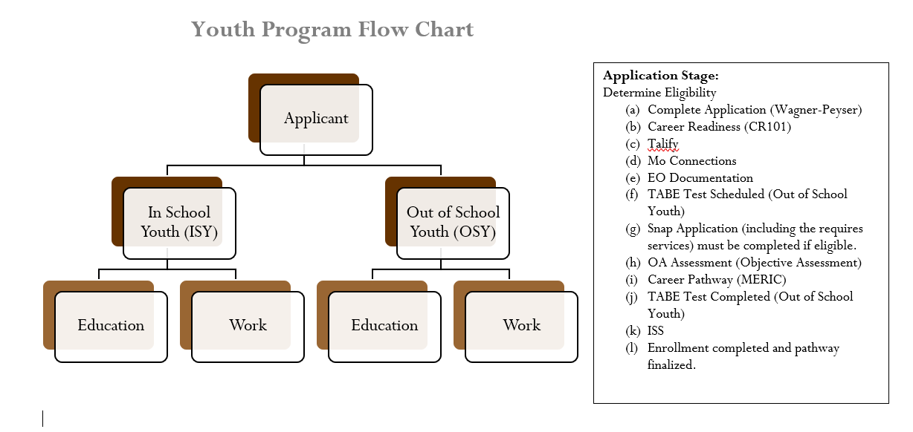
The flow chart above is a guidance tool for youth staff as many issues are dealt with during appointments such as addressing youth barriers and complete explanation of WIOA Youth services. The youth will also be given referrals to other agencies, as deemed necessary, to address identified issues or barriers in their current situation and any of the 14 program element activities needed.
If earning a high school equivalency is identified as a goal and remediation is determined as needed, plans will be made for that course of action. If work experience is more appropriate, an interview will be set up with an employer offering the opportunity to work in a field of interest that matches a career pathway identified by the youth.
Placement of youth at a worksite requires a Worksite Agreement, Training Plan, Orientations for worksite supervisors and youth to be completed. During the time youth are placed at a worksite, monitoring and meetings will occur on a regular and consistent basis with any and all issues being addressed at that time.
Throughout the course of participation, the youth staff will provide access to tutoring as needed, they will offer opportunities for the youth to meet with representatives from local colleges and universities, Job Corps representatives, military recruiters, protentional employers, among others.
Upon completion of participation, the youth is placed into WIOA follow-up services and the youth advisor makes at least quarterly contact with them for 12 months to ensure successful transition to education and/or employment.
h. The procedures for serving Youth that are most in need (homeless, disabled, offenders, etc.);
In order to determine priority of service, the youth advisors discuss barriers to employment with the participants. Some of the barriers reviewed are as follows:
- Basic skills deficient, runaway, offender, homeless, pregnant/parenting, school dropout, foster child/aged out of foster care, individual with a disability, English language learner, subject to juvenile/adult justice system etc.
- Locally, the definition for “requires additional assistance to enter or complete an educational program or to secure or hold employment “involves the following:
  - placement in substance abuse facility, alternative residential care or group home;
  - behavioral problems at school, truancy, family literacy problems, witness or victim of violence, chronic health problems;
  - repeated suspensions from educational facility or employment situation, second generation public assistance.
Also addressed are those youth who have had three or jobs within the past six months, are considered “under-employed” (working less than full-time, needs employment in education-related filed, or working for minimum wage with no benefits or opportunity for advancement) or those youth living in an economically depressed rural area with limited opportunities for gaining work maturity skills and/or career exploration in a chosen career pathway.
There are also criteria in place to determine who could benefit most from youth training and employment programs. These criteria include: resources available for basic skills enhancement, agreement to actively participate in AEL/HiSet classes for those out-of-school youth who are literacy/numeracy skills deficient, and/or requiring improvement in employability skills.
i. The identification of the partnerships and describe the coordination of services with other agencies within the LWDA.
The Workforce Board and Subreceipts coordinate with several agencies in each of the counties within the region. These agencies include but are not limited to: Missouri Valley Community Action, West Central Missouri Community Action Agency, State Fair Community College, Crowder College, University of Central Missouri, Center for Human Services, the local school districts in every community, Rehabilitation Institute of Kansas City, Vocational Rehabilitation, Boys & Girls Clubs of West Central Missouri, Johnson County Board of Services, WILS, Pathways, Burrell Behavioral Health, Catholic Charities, Family Support Division in each county, Job Corps, Job Point, Salvation Army, local Housing Authority offices, community food pantries and clothes closets, many businesses and industries within each community, local homeless shelters and juvenile justice/probation and parole officers, among others.
Services are coordinated through service referrals, attending local inter-agency meetings, giving presentations to various agencies, meeting with local business and industry for the development of worksite agreements, meeting with local school counselors, regular meetings with Adult Education and Literacy instructors in each area. Each participant signs a release of information that is utilized to ensure that they are being provided with the services that are available to them.

38. Innovative Service-Delivery Projects for OSY

Provide a description of any innovative service-delivery projects for OSY currently operating in the LWDA or a project the Board is planning to implement. Describe the Board’s involvement in the projects, and the Board’s efforts to continue involvement and funding for the continuation of these projects.
The West Central Region is in the implementation stages of the Engage Application. Eckerd Connects has teamed with experienced developers and designers to build, test, and deploy a client support application that every participant our organization works with can utilize from a mobile device. While this will not replace in-person case management it will enhance the services delivered by increasing engagement and connecting every person we serve, particularly young people who exist in a world that priorities virtual services with resources they need to be successful.
The region is also in early discussions of the possibility of implementing Eckerd Connects Project Bridge which provides transitional services to individuals ages 11-21 reintegrating to their home communities from juvenile justice residential commitment programs. Through an innovative collaboration of organizations, Project Bridge provides educational, mentoring, vocational, and transportation services to help our young people achieve stable and successful lives and avoid re-entry into the criminal justice system.
Agricultural Employment Services (AES)

39. Migrant and Seasonal Farmworkers / Agricultural Employment Services

WIOA section 167 provides the framework for agricultural services delivery. National Farmworkers Jobs Program (NFJP) services and grants are implemented at 20 CFR Part 685, as proposed. The current Section 167 Grantee, UMOS—United Migrant Opportunity Services, must be included in the MOU as the NFJP partner. The Plan should address how the LWDB will cooperate with UMOS and the State Agricultural Employment Services office to provide employment and training services to this population.
The Workforce Development Board has a MOU with UMOS/AES and cooperates with the State Agricultural Employment Services staff and the United Migrant Opportunity Services (UMOS) program in regard to services in the West Central Region. According to the Missouri Economic Research and Information Center (MERIC), some of the largest agricultural employers in the region are Tyson Poultry and Conagra Foods. The region also has a high concentration of animal production jobs. The Job Centers in the West Central Region are striving to provide unduplicated/integrated services across all programs with accommodations being made whenever possible to engage agricultural workers and business owners in value-added services. The Job Centers provide a full range of employment services, benefits and protections to include full range of counseling, testing, job and training referral services to the populations served by these two programs.

Business Services

40. Employer Engagement

Describe the strategies and services that will be used in the LWDA facilitate engagement of employers in workforce development programs, including small employers and employers in in-demand industry sectors and occupations.
- Continuing to participate in Regional Planning Commission CEDS committee.
- Encouraging staff to meet with employers one-on-one to address their needs and to identify career pathways within their companies as well as working with them to hire and retain a skilled workforce.
- Working closely with economic developers in the region.
- Supporting job training opportunities.
- Providing opportunities for job fairs and hiring events.
- Staff will continue to present information at public and private meetings/organizations
- Employers from small and large businesses are represented on the Local Workforce Development Board
- Continuing to work with the Office of Workforce Development’s Employer Engagement Team.
- Virtual Employer Workshops are offered to inform employers of services available to them though the job centers.
41. Services to Meet the Workforce Needs of Employers

Describe how the Board coordinates and provides comprehensive and integrated workforce system services to businesses, including the development and delivery of innovative workforce services and strategies to meet the needs of area employers. Explain the collaboration with Missouri Job Center Jobs Teams to facilitate recruitment and meet business demand.
The West Central continues to participate in the Nexus Group meetings. This group coordinates services offered by workforce partner agencies. It is made up of organizations involved in job development throughout the southern part of the region. The group discusses the needs of area employers and shares information regarding their need and hiring practices. The northern part of the region has implemented the Empowering Employers Group. This group brings community resource partners and employers together to share information. The community resource partners share services they could provide to and the employers share what their needs are.
Access points and 100% virtual services have been established throughout the region to enhance access to services for both job seekers and employers. Employers are encouraged to register employment opportunities into MoJobs.
Input is provided from private business sector members of the local board that aids in the development of strategies needed to meet the needs of area employers.

42. Economic Development

Describe how the Board will better coordinate workforce development programs with economic development including how the LWDB will promote entrepreneurial skills training and microenterprise services.
The Executive Director of the LWDB serves on the Pioneer Trails Comprehensive Economic Development Strategy committee (CEDS). The committee encourages entrepreneurship, business development and business expansions within Johnson, Lafayette, Pettis and Saline counites.
Economic Development is represented on the Workforce Development Board and that individual also participates on the Planning and Operations Committee which oversees job center activities, selection of service providers, performance, professional development of staff, etc.
Most Economic Developers in the region have been engaged in the attainment of their county’s Certified Work Ready Community Certification to improve their ability to attract new businesses to their areas.

43. Sector Strategy Initiative / Career Pathway

Describe the Board’s sector-strategy initiative. Describe how the Board will be collaborating and aligning resources of all partners, public and private, toward developing a talent pipeline, and how that alignment will create meaningful career pathways for workers possessing skill levels serving important regional industries. Indicate how system services will be framed by industry sectors that are data driven, regionally designed, and guided by employers and how these strategies will be sustained. Include the methods the Board will be using to inform and engage key public and private stakeholders in the development of sector-strategies and career pathways.
Business services are regionalized and coordinated among partners to give diverse solutions. Training is driven by business needs (demand driven). Credential attainment is aligned to identified industry needs and targets. Job center organization, partnerships, customer flow, and service planning and delivery are sector focused. Long-term career development along with clear pathways in industry sectors are targeted.
The Missouri Hospital Association sustains sector work by holding meetings three times a year with healthcare partners that the LWDB participates in. The board held several manufacturing sector meetings but there was little interest in sustaining a partnership in that way.
The board strives to enrich industry-driven sector strategies that are championed by business and industry to drive career pathways and to work with local economic developers in bringing industry together for collaboration.

44. Business Services Plan

Boards shall maintain a Business Services Plan, outlining team members, including WIOA core and combined partners, and the marketing and outreach roles and expectations of team members. The Business Services Plan also should outline the team’s purpose, goals, and policies and procedures to ensure seamless delivery of services, avoid duplication, and ensure feedback to the Board’s Job centers. The plan should explain how the services provided by business service staff will be recorded in the client case management system for the calculation of two types of Effectiveness in Serving Employers Measure. (1-number of businesses served and 2-market penetration of businesses in the area). Include the Business Services Plan as Attachment 30.
See Attachment 30.

Innovative Service Delivery Strategies

45. Missouri Re-entry Process / Ex-offender Initiative

Describe how the LWDB will support the Missouri re-entry process / ex-offender initiative. Include the services to be provided for ex-offenders and the process to be used to identify employers willing to hire ex-offenders.
The West Central Board is aware that each Probation and Parole District has a Missouri Re-entry Committee (MRP). These Committees offer the best resources and support for offenders returning to a community. Successful transitions from incarceration to a community is essential to local, state, and national efforts to increase public safety and manage public spending. Information can be shared through the MRP meetings regarding employment information and resources and other services available through the Job Centers such as the Federal Bonding Program which is a no-cost job-incentive program intended to increase the hiring of job seekers and promotion of employers considered “at-risk”.
Job Center staff remain ready to assist with labor market information; career exploration and counseling; assessments; workshops on resume preparation, interviewing, basic computer operation, financial literacy, etc.; National Career Readiness Certificate (NCRC) remediation and/or testing as well as referrals to appropriate programs or partner agencies for assistance with other identified barriers to employment.

46. Work-based Learning / Transitional jobs

Describe the Board’s innovative strategies for promoting and increasing enrollments in the work-based learning programs, such as Registered Apprenticeship, On-the-Job Training (OJT), Work Experience, Internships, Incumbent Worker Training, Transitional Jobs, and Customized Training. Include processes to target and encourage employer participation.
The West Central Region’s Board views work-based learning programs as a proven strategy for developing a talent pipeline of qualified worker for employers and has set a goal of promoting these programs to increase the number of individuals being served through them. Board members and Job Center staff continually share information with employers and through community events to meet these goals. The region has seen an increase in On-the-Job Training and Incumbent Worker Training due to these efforts.

County | Occupation Title | USDOL Registered Apprenticeship Program Sponsor
Pettis | CNC Operator and Programmer | State Fair Community College
Pettis | Drafter, Mechanical | State Fair Community College
Pettis | Electrician (Interior Electrician) | Central MO Independent Electrical Contractors
Pettis | Facility Manger | State Fair Community College
Pettis | Heating/Air Conditioning Installer | Home Heating and A/C
Pettis | Heavy and Tractor Trailer Truck Driver | State Fair Community College
Pettis | Industrial Machinist System Technician | State Fair Community College
Pettis | Information Technology Specialist | State Fair Community College
Pettis | Machinist (Precision Machinist) | State Fair Community College
Pettis | Office Manager/Admin Servies | State Fair Community College
Pettis | Welder, Combination | State Fair Community College
Saline | Electrician (Interior Electrician) | Marshall Technical Training

The board’s #1 goal (see section on Strategic Elements) is to support job training opportunities (OJT, Transitional Jobs, Incumbent Woker, Apprenticeships, Work Experience, Skill Certificates, etc.) by:
- Placing participants in training opportunities that closely match their interest assessments.
- Addressing current and emerging skills gaps identified through sector partnerships.
- Enhancing the alignment of career services across all partner programs through an integrated model of service provision.
- Integrating work-based and classroom-based instruction.

47. Trade Adjustment Assistance

Describe the Board’s strategies for ensuring customers are aware of the Trade Adjustment Assistance (TAA) program and are co-enrolled into both WIOA Dislocated Worker and TAA, except in extenuating circumstances? (Integration of Services or Co-enrollment Policy should be Attachment 24)
The West Central Region provides information to customers regarding the availability of Trade Adjustment Assistance through conversations with staff. A local policy exists to complete co-enrollments for all programs in which a participant is eligible.
See Attachment 24.

48. Missouri Community Colleges

Describe how the Board will coordinate with the local community colleges. Please describe in depth the referral process of participants between the Community Colleges and Job Centers. Please include the MOU (cooperative agreement) between the Board and Community Colleges if your LWDA has any as Attachment 31 to the Plan.
A long-standing partnership exists between the Workforce Development Board and State Fair Community College with an emphasis in the areas of Adult Education and Literacy and Lifelong Learning and National Career Readiness Certification.
State Fair Community College refers students to the Job Center when in need of training or other assistance and the Job Center refers individuals to the college in need of additional training information or AEL program assistance. Job Center services are provided on the campus located in Clinton.
See Attachment 31.

49. Incumbent Worker Policy

If the LWDB has an Incumbent Worker Policy, please include it as Attachment 32. If not please include a statement that the LWDB does not have an Incumbent Worker Policy.
See Attachment 32.

Strategies for Faith-based and Community-based Organizations

50. Faith-based Strategies

Describe those activities to be undertaken to:
(1) increase the opportunities for participation of faith-based and community organizations as committed and active partners in the One-Stop Delivery System; and
There are many opportunities to partner with faith-based and community-based organizations through the work force system as many of the same customers are shared. Strong partnerships have formed around housing as this is a big issue for very small communities as well as larger ones. Domestic violence shelters frequently bring clients to the job centers to access services.
(2) expand the access of faith-based and community-based organizations’ customers to the services offered by the One-Stops in the LWDA. Outline efforts for conducting outreach campaigns to educate faith-based and community organizations about the attributes and objectives of the demand-driven workforce development system. Indicate how these resources can be strategically and effectively leveraged in the LWDA to help meet the objectives of WIOA.
Distribution of workshop calendars are distributed to many of the local organizations/entities. Job Center staff share the programs and services available with local Ministerial Alliance Groups and churches. Staff are often asked to speak at meetings of local non-profits regarding services available through the Job Centers. Information regarding services is often made available to food pantries in the area for them to share with individuals about services, hiring events and workshops.

REGIONAL PLANS
Regional Planning Guidance

51. Regional Plans

Missouri has designated 14 Local Workforce Development Areas (LWDAs). In accordance with WIOA sec. 106(c)(2), each of the LWDAs establish a Plan; however, collaboration must exist among the Kansas City and St. Louis Economic Regions for the creation of Regional Plans composed of the following:
1) For the Kansas City Region, one Regional Plan for the local planning areas of Kansas City and Vicinity Region and the East Jackson County Region; and
2) For the St. Louis Region, one Regional Plan for the local planning areas of: The City of St. Louis Region, the County of Saint Louis Region, the County of St. Charles Region, and the Jefferson/Franklin County Consortium Region.
While this establishes 13 Boards that are encouraged to collaborate, cooperate, and plan across common needs, they will not explicitly submit a Regional Plan. This establishes two Boards within the Kansas City Region that must contribute to a Regional Economic Plan for the Kansas City regional economy and four Boards within the St. Louis Region that must contribute to a Regional Economic Plan for the St. Louis regional economy.
Boards within the Kansas City and St. Louis regional economic planning areas must complete a regional planning requirement by including within each original LWDB Plan a Regional Economic Plan that is identically shared by all Boards in each economic region.
Include the Regional Plan as Attachment 33. Copies of Local Plans from other LWDAs in the region are not required for your Local Plan. Please submit the combined portion of the Regional Plan with signatures of the CEOs, Chairs and LWDB Directors.
NOTE: Following approval of the Local Plan and Regional Plan, plans will be required to be posted on the LWDB website. Any updates or plan modifications will be required to be posted by the LWDB after approval. Please keep a current Local Plan and Regional Plan, if applicable, available on your website at all times.
A Regional Plan is not required for the West Central Region.

REQUIRED POLICIES AND ATTACHMENTS

All local policies relating to WIOA are required to be approved by OWD and listed as part of the required attachments to the local plan regardless of whether or not they are required by the LWDB, state or federal guidelines. The below list is not an all-inclusive list of federal regulations. At any time, the LWDB, state, or federal guidelines may require additional policies beyond the list below:
1. List of Comprehensive, Affiliate, Specialized and Other Centers and One Stop Operators
2. Memorandum of Understanding with IFA and Cost Sharing Budgets with All Partner Signatures
3. Chief Elected Officials Consortium Agreement and Bylaws
4. Local Workforce Development Board Membership List, Standing Committees, & Certification Letter
5. Local Workforce Development Board By-Laws and Attestation Form - Form provided
6. Local Fiscal Agent
7. Planning Budget Summaries (PBS)
8. Conflict of Interest Policy - Local Workforce Development Board, Staff, and Contracted Staff
9. Financial Procurement Policy / Financial (General) Policy
10. Complaints and Grievance Policy – Nondiscrimination, Programmatic
11. Sub-state Monitoring Plan and Policy
12. Supportive Services Policy – General, Needs Related Payments Policy for ADLT and DW
13. Adult Priority of Service Policy
14. Expenditure Rates Policy
15. Training Criteria Policy (AD & DW)
16. Youth Barriers Eligibility Policy – OSY ISY additional assistance barrier
17. Youth Incentive Payment Policy
18. Veterans Priority of Service Policy
19. Basic Skills Assessments (Testing) Policy
20. Individual Training Account (ITA) Policy
21. Eligibility Policy (Individualized Career Services)
22. Accessibility Policy – Persons with Disabilities
23. Accessibility Policy - Persons with Limited English Proficiency
24. Co-enrollment Policy
25. Adult Education and Literacy Policy (AEL Policy)
26. VR/RSB Coordination Policy
27. Youth Apprenticeships Policy
28. ETPL Policy
29. Employment Transition Team Policy
30. Business Services Plan and Policy
31. MOU (Cooperative Agreement) between the Community College & LWDB
32. Incumbent Worker Policy
33. Regional Plans (St. Louis / KC)
34. Accommodation Policy
35. Confidentiality Policy
36. Customized Training Policy (if applicable)
37. Facilities
38. Cost Allocation Policy
39. Cost Accounting Policy
40. Financial Reporting/Cash Draw Request Deadlines
41. Fraud, Waste, Abuse, and Criminal Activity Policy
42. Internal Accounting Policy
43. Local Bonding Policy
44. Payments to Employers Policy
45. Follow-up Policy Adults and Dislocated Workers
46. Follow-up Policy Youth
47. Harassment and discrimination Policy
48. Nondiscrimination Policy
49. On-the-Job Training Policy (including employer disputes, nepotism, and modifications)
50. Personnel Policies (leave, travel, facilities closing)
51. Records Policy (access, Sunshine, retention, and destruction)
52. Transitional Jobs Policy (if applicable)
53. Work Experience Policy – Adult
54. Work Experience Policy – Youth
55. Apprenticeship Policy
56. Selective Service Policy
57. Statement of Assurances - Form provided

